Improving Project Portfolio Management (PPM) for Improvement Projects

* Using the ImprovAbility[1] model together with CMMI[2] to achieve success with improvement at Vestas Windsystems

Jan Pries-Heje1, Peter Møller Jakobsen2, Morten Korsaa3, and Jørn Johansen3

1 Roskilde University, Roskilde, Denmark

[janph@ruc.dk](mailto:janph@ruc.dk)

2 PMO Department, Vestas Windsystems, Aarhus, Denmark

[pmj@vestas.com](mailto:pmj@vestas.com)

3 Whitebox, Hørsholm, Denmark,

[mk@whitebox.dk](mailto:mk@whitebox.dk), [jj@whitebox.dk](mailto:jj@whitebox.dk)

Abstract

Project Portfolio Management (PPM) focus on the integration and alignment of projects with the business operation in order to achieve most value and cost-efficiency for the investment in projects. PPM is often a challenge and especially so for improvement projects where PPM is considerably underdeveloped. In this paper we present an approach that combines the ImprovAbility model and assessment with a version of a CMMI assessment developed by the Danish company Whitebox. This approach was developed in the world-leading Wind Turbine Company Vestas. The paper presents and discusses this new way of evaluating a portfolio of improvement projects and combine this evaluation with the effect they have on the CMMI maturity level. Further, the paper demonstrates how the combination of a strong senior management requirement for improved maturity and the focus on getting the most value out of PPM made it possible for Vestas to become “better at getting better”.

Keywords

Improvement; maturity; process improvement; success with improvement; CMMI®, ImprovAbilityTM;

Introduction

Project Portfolio Management (PPM) focus on the integration and alignment of project ideas and ongoing projects with the business operation. “It brings projects into harmony with the strategies, resources, and executive oversight of the enterprise and provides the structure and processes for project portfolio governance” [1]. PPM is an important dynamic capability that has demonstrated its value in empirical studies [2]. It also has demonstrated its value in relation to innovation [3]. The ‘portfolio’ in PPM is the set of projects either being considered or going on. All the major organizations defining project management have defined what is meant by and included in PPM; see for example [4]. And a book on PPM coins it “… the biggest leap in project management technology since the … late 1950s” [1].

PPM is however a challenge for many organizations even if you subscribe to the best practice and theory on PPM. E.g. an empirical study of found that “Although companies manage project portfolios concordantly with project portfolio theory, they may experience problems in the form of delayed projects, resource struggles, stress, and a lack of overview” [5]. Another more recent study found that companies struggle with the sub-optimization and changes among their projects, even if various normative instructions and good practices have been introduced for PPM [6].

It is key to any PPM effort that one should align the strategy of the company with the business. What is relatively new is that you need “structural alignment”, that is aligning your organisational structure as well [7].

Another challenge for PPM is the behaviour of internal stakeholders [8]. Not so much the portfolio manager – that was found to insignificant – but more the behaviour of management especially top- and senior-management.

In any organization, there may be projects of many kinds. Product development projects aimed at a market and having an attractive business model will typically receive more attention than more internally-oriented Improvement projects aimed at improving internal processes in an organization. Hence, with an outset in the existing literature there is a research question begging to be answered namely: *How can we improve PPM for improvement projects?*

The way companies often organise and manage improvement efforts is by using a process improvement model. A few years back a new standard for process improvement called the ISO 33014 standard [9] for use in IT organizations was published. The standard operates at three levels called strategic, tactical and operational. At the strategic level an organization are to start with identifying business goals, identifying the scope of organizational change, selecting models and methods and identifying roles, and then identify the overall change strategy. This then leads on to the tactical level where the more specific planning of the organizational change and process improvement projects takes place.

One way of applying the standard is by using one of the maturity models such as ISO/IEC 330xx [12] or the Capability Maturity Model Integrated [10], and use the newly developed ImprovAbility model [11] (that specifically implements the ISO 33014 standard) to strengthen the success rate for the improvement initiatives identified in the maturity assessment. The ImprovAbility model includes a list of 20 critical monitoring parameters and an analysis method to assess an organisation.

However, even if the use of maturity models and the ISO standard is relatively widespread to identify improvement projects they do not specifically address the project portfolio management for improvement projects. Thus, a good follow to our research question above is *whether one can use these improvement models to improve PPM for improvement projects?*

To answer that as well as the overall question we have undertaken a case study at Vestas, a global energy company dedicated exclusively to wind energy.

In the remainder of the paper we will, in section 2, first give a more specific account with details of the ISO 33014 standard [9], the ImprovAbility model [11], and the CMMI [10]. Next, in section 3, we discuss the second research question, namely in what way these improvement models can be used to improve PPM? In section 4 we present the Vestas case and how the improvement models were used in Vestas. In section 5 and 6 the PPM evaluation after a first and a second round is presented. Then in section 7 follows a discussion. And finally, in section 8, a conclusion answering both the overall and the more detailed research question.

The improvement models

Some years ago the ImprovAbility model was developed in a very large Danish research project with two of the authors of this paper as project manager and responsible for research. The ImprovAbility model soon became part of ISO/IEC 33014 [9] standard for process improvement. As can be seen from Figure 1 process improvement operates at three levels; strategic, tactical and operational.

At the strategic level an organization must start with identifying business goals, identifying the scope of organizational change, selecting models and methods and identifying roles, and then identify the overall change strategy. Then follows the tactical level where the more specific planning of the improvements takes place.

Many organizations perform process assessments (Step 3, Tactical level, Improve Processes) and get an insight in the maturity level for the organization, capability levels for the processes and several recommendations and ideas for improvement projects. Some of these recommendations and ideas leads improvements programs and projects realized as projects at the operational level. Often it is a PMO, quality or method department, who manage and control these projects.

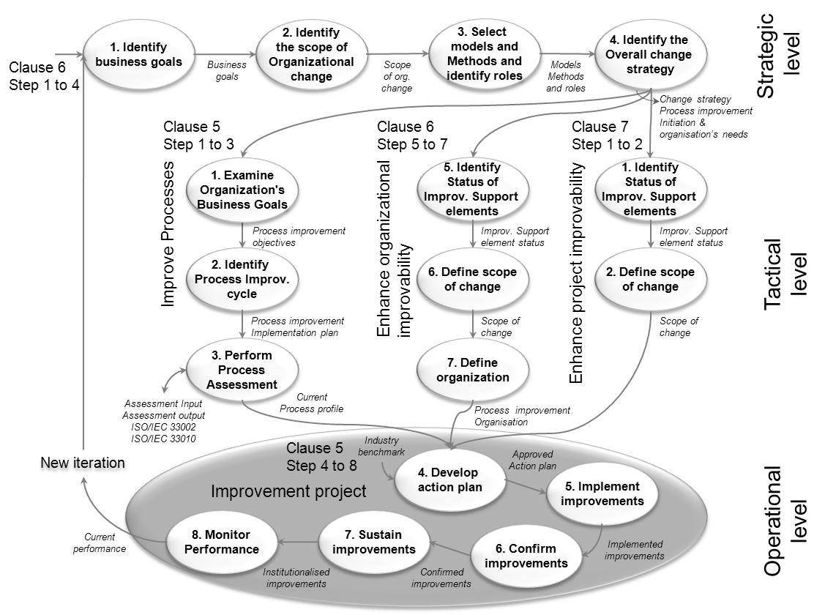

Figure 1 Overview of the ISO/IEC 33014 [9]

But as mentioned earlier in this paper, success with these programs, projects or initiative are unfortunate rare. So, if one would like to know how good the organization is to get success with the improvements –the ImprovAbility model can provide the answer. This is modelled in ISO/IEC 33014 (Clause 7, Step 1, Tactical level, Enhance project improvability). With this it is possible to evaluate a set of improvement projects against the enhancement parameters in the ImprovAbility model, and get a figure for the ability to improve.

If we perform this analysis over time it is also possible to see if the organization gets better at improvement in general.

Add to this what impact of the improvement projects has on the process capability. With this knowledge, you will know which projects have the best influence on the improvement of the organizational maturity and how likely it is they will succeed.

Using improvement models for PPM

While communication is always a challenge it is even worse when it comes to improvement projects. It is difficult to write a clear and objective business case including effort and expected benefit, which can be measured. If you increase sale 10% for a product it has an intuitively understandable and specific impact on the bottom line. If you improve the capability of a given process with 10%, it is not intuitively understandable in the same way, and the impact on the bottom line is not as specific. However, it remains the responsibility of senior management to prioritize between those two very different types of investments. The challenge is to provide them with high quality insights as basis for this prioritization.

At the next level of abstraction, we find the effectiveness of implementing the improvements. This become important for the leadership soon after the focus is established, but is even more complicated to measure. We need measures that can communicate how well the investments in improvements are building up competences that supports the business goals and company vision.

Typically, a higher maturity level not is the final goal for improvement projects. But the maturity level is a powerful indicator of process performance – and what is more important – it is a measure that senior management can relate to and use for target settings.

In this case, the maturity measure is based on CMMI [10]that elicits the status of the development process on one page. In the case of Vestas, the assessments was carried by the Danish company Whitebox to which two of the authors of this paper belong. The result of the assessment is presented as capability levels in quartiles per process and a single figure, e.g. 2.25. Along with the analysis follows a set of recommendations for improvement projects on specific processes. A maturity assessment delivers a clear and simple measure, which can be used by Senior management to identify improvement projects, focus the improvement effort and clearly communicate goals for improvement.

But it is often seen, that the result of a maturity assessment is neglected and not used for anything. Our best guess is around 50%. Success with improvement projects needs a Senior management, which can see the benefit of more professionalism in development and believe the investments in improvement projects will be beneficial in relation to less rework, less product errors, more reuse, less subculture or silos in the development organization – or other benefits related to visons or goals.

In reality, all companies have a lot of improvement projects going on. We have seen large companies with several hundreds of ongoing improvement projects. Some well-known to management and some flying under the radar. The reality is that most organizations does not know have many projects they have, and what effect they eventually will have. How can we focus and be more efficient in improving the development organization?

First step is to establish a list of initiatives, simply by asking the employees what they are doing to improve the way they are working. With this list, it is possible prioritize those who seems most appealing.

Second step is to evaluate all the projects related to how “healthy” they are by using the ImprovAbility model. It has 17 success enhancement parameters, which characterizes the “healthiness” of an improvement project (for an organizations ability to improve 20 enhancement parameters are used). By interview of the project manager and eventually other key persons, the assessors can score the parameters and give a score for the project. The parameters are shown in the figure 2 below in the 4 categories: Initiation, Projects, In Use and Foundation. The parameters are described in ISO/IEC 33014.



Figure 2 The ImprovAbility enhancement parameters for success with improvement projects

During the interview with representatives from the improvement project, each enhancement parameter is scored through a set of questions. In Figure 3 below is presented a set of questions related to one of the enhancement parameters – here Deployment means. The questions behind the enhancement parameters is at the highest level described in the ImprovAbility book [11].

Across all parameters you also get a figure per improvement project on a scale from 1 to 4 (1 is lowest and 4 is highest).

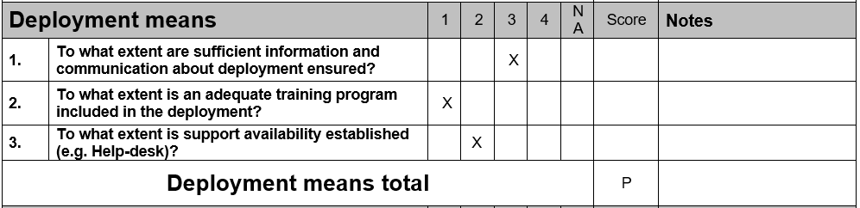

Figure 3 Excerpt from questions used to measure “Deployment means”. Scale: 1 = not at all (N), 2 = partly (P), 3 = largely (L), and 4 = fully (F), with NA = not applicable. Same scale as used in ISO/IEC 330xx.

When you conduct an ImprovAbility assessment, you are given an overall ‘helicopter’ view of the improvement project. Given that most of the parameters are very non-technical, you will be forced to focus on the surroundings of the project—the culture, the management, the team-work, the interfaces to other stakeholders—and put the product itself in the background for a little while. All important things for success with an improvement project.

The entire project team benefits from the assessment process, as everyone can discuss issues and matters that many usually don’t have time for. After the assessment, communication and negotiation between the project team and Senior management become easier.

And - important for the overview on all the improvement projects – every project gets a score, which is an average of the enhancement parameters. This is also a measurement, which is easy to present and important to establish an overview of all ongoing improvement projects across the organization.

This paper will demonstrate how it is possible in one figure to show the “health” of a set of improvement projects and how the organizations ability to improve - improve over time.

We believe such an insight to be very valuable for an organization for navigating in the landscape of improvement projects – especially for Senior management. Which projects need more support, which projects need to be reconsidered in relation to scope, which projects must be reconsidered in general, and which projects seems to be successful and have the right scope?

Third step is to evaluate what effect each initiative will have on the organizations maturity/process performance. This is done by the maturity assessors who based on the models evaluate how the improvement projects will affect the set of specific and generic process practices on a scale from 1 to 10 (1 equal nothing; 10 equal complete).

So, the problem we by this research will demonstrate and validate is for a set of improvement projects in an organization to be able to sort and show their “health” combined with the impact on a higher maturity – as a one pager – and how it develops over time.

Vestas Case and how it was done

Vestas, for which this analysis took place, is a very large Danish company – the largest wind turbine company in the world, which operate globally and together with a lot of suppliers. The company develops very large and complex products, which include delivery at the operation place (a project itself) and includes ongoing support for many years afterwards.

At Vestas there was established an improvement program to focus on the recommendations from theassessment.

Identification of the improvement projects

After the Whitebox assessment, which came up with several recommendations for improvement projects, the organization took the decision to ask the many development departments to make a list of the improvement projects they had ongoing. It was the PMO department, which took that task and handled the process of this improvement project investigation.

It came as a surprise that more than 140 improvement projects were active – and a deeper investigation would have revealed even more. All these improvement projects were local projects driven by the departments by enthusiastic employees who had the specific need for the improvement.

Given the very different nature of all the improvement initiatives, it was decided to focus on those that were expected to have the greatest impact on the company maturity.

The Danish company Whitebox helped with evaluation of the 140 improvement projects and identified the 40 most relevant improvement projects to be evaluated. These 40 projects were then supported and managed by the PMO departments as focused CMMI improvement projects.

Evaluation of the improvement projects

The PMO department and Whitebox scheduled an ImprovAbility based interview with each of the 40 projects over a two-week period. One or two persons from each improvement project was taking part in the interview, performed by two assessors from Whitebox.

Before the interviews took place, each improvement project was asked to send information on their improvement project, such as: project name: Business goal, Deliverables, Resources, Stakeholders, Budget, Schedule, Hours used, Activities planned, Activities finished, Deployment activities, Risks and Mitigations.

The Whitebox assessors did the interview – one performed the interview and scored the enhancement parameters during the interview, and the other one took notes. After the interview the two assessors aligned their opinions and eventually adjusted the score. In reality it ended with interview of 37 improvement projects.

Analysis

To establish the overview for the PMO required two separate steps for each improvement initiative. The first step was to score the ImprovAbility enhancement parameters using the NPLF – scale from ISO/IEC 330xx [12]. This was done during and just after each interview. An average score for each category in the ImprovAbility model was calculated as well as the overall score for the project. This is done from a scale from 1 to 5, and represent the improvement projects “chance of success”.

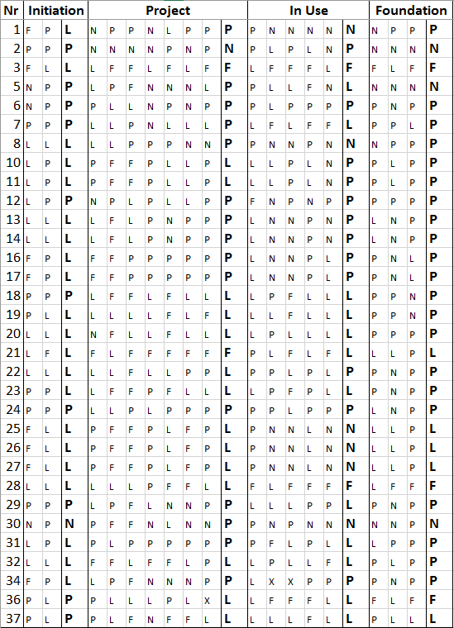Next step was to evaluate the expected impact the improvement project would have on the organizational maturity (CMMI). This was done on a scale from 1 to 10, based on the assessors’ evaluation of the information gathered during the interview. This was done in the evening after a day with several interviews.

After all the interviews were performed a large set of data was available for the analysis.

The data for each improvement project is made up by a score for each enhancement parameter, which is aggregated to a score for each category (Initiation, Project, In Use and Foundation – marked as bold letters).

This identified Deployment Strategy and Deployment Means as the weakest parameters. Supporting these will have the greatest impact on the chance of success for each of the improvement projects and for Vestas all together.

Figure 4 ImprovAbilityTM score for the improvement initiatives

First PPM evaluation at Vestas

In Figure 5 below, the “Bless and follow up” quadrant was the initiatives that did not need a lot of attention, but was expected to have a high impact. Suggested PMO activities: Reporting and steering group.

Below in the “Strong support needed” quadrant was those improvement projects that needed support from the PMO department if they should deliver the expected high impact. Suggested PMO department activities: Training, support, resources, prioritization, conflict solving, mentoring,….

In the top left “Consider a more ambitious scope” quadrant was the improvement projects that was in a good shape, but had less impact. Maybe good enough, but maybe the PMO department could use the inertia and boost the scope.

In the “Reconsider” quadrant was those that maybe was not worse the effort, but in this case, they were all ok.

This figure was the input to PMO department as the first overview.

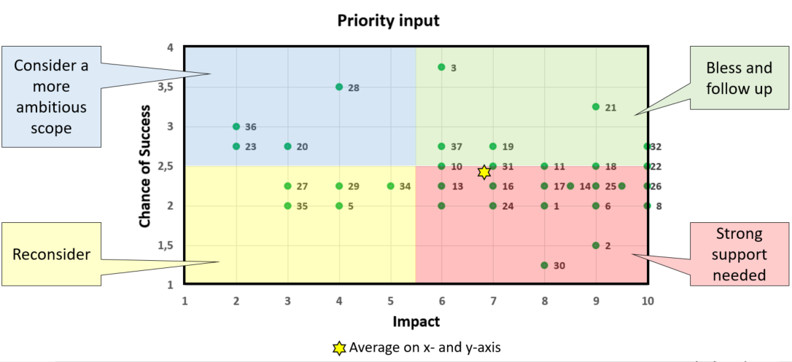

Figure 5 First evaluation - Chance of success versus impact

Second PPM evaluation at Vestas

8 month later, a new group of improvement projects was initiated and ready to be included in the PMO departments overview of ongoing improvement initiatives.

8 improvement projects where rescoped/restarted from projects from the first evaluation and were now part of 6 of the projects in the second analysis due to more focus and support – and are therefore part of both analysis. In total we ended with interview of 26 improvement projects.

Same analysis was applied, and the effect of the increased focus was visible. The selected projects had a higher impact and a greater chance of success, which is illustrated by the change from Figure 5 to Figure 6 where you can see the “average star” has moved to a higher degree of change for success and higher degree of impact on the maturity.

A set of data (as illustrated in Figure 4) was also generated for the second analysis. If the two set of data are compared it is clear, that all enhance parameters have improved – with the largest positive difference for the parameters: Sensing urgency, Idea processing, Involving others and Management Competences.

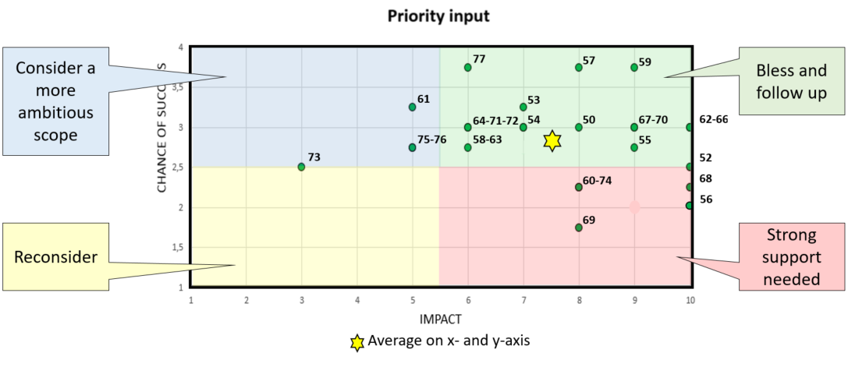

Figure 6 Second evaluation - Chance og success versus impact

This figure was also given to PMO department as the second overview.

## Development of the ability to improve over time

The second analysis revealed that both the impact and the chance of success has increased over the 8 month.

This is of course due to more factors, but the end result is that the overall organizational maturity will increase – faster. Which by the end of the day is the sole purpose of this exercise?

The increased impact was likely and partly due to:

1. Improvement projects initiated by management as opposed to initiated by engineers
2. Better prioritizing of improvement projects for the evaluation

The increased chance of success was likely and partly due to:

1. Increased focus on the importance of treating the projects the same way as product development projects
2. Allocating hours and budgets and hour registration
3. Looking for successes
4. Organizational changes
5. Promotion of leaders with a strong improvement agenda

The breakthrough with this analysis is that it has proven the effect, and provided the leadership with insight to speed up the process even more.

The Whitebox analysis has also enabled or supported Senior management and PMO department in the following activities as part of leading process improvements:

* Organizing improvements to ensure success
* Change of scope for optimal benefit
* Knowledge exchange between different – but related – improvement projects
* Collaboration between projects
* Mergers of improvement projects when they share the same goal and must be global oriented
* Performance expectation management in the organization. Is the roadmap realistic?
* Initiation of new projects in weak processes that is not covered by the actual projects
* Include relevant, but not yet identified, stakeholders in the projects

Demonstrating progress on specific enhancement parameters.

Discussion and next steps

The accuracy of both the “chance of success” and the “impact” is obvious depending on the level of analysis performed. In this specific case a light version of both the ImprovAbility analysis and the CMMI impact analysis was performed and seemed sufficiently accurate, since the use of the results was internal, and it was not used as the final answer. The responsible managers have in all cases applied their final judgement to all decisions. What is unknown is what benefit a deeper analysis would have brought.

The analysis was performed by assessors who have performed hundreds of maturity assessments and were responsible for the project that developed the ImprovAbility model. What is unknown is what level of experience is required to perform the analysis.

A deeper analysis of the “chance of success” could almost auto-generate a specific risk profile for each improvement project from the ImprovAbility model. When would this be valuable? We have no doubt that this approach speed up the organizations ability to improve. Can it be measured how much is however up for further discussion. Or would a senior management consider “being ahead of competition” as a strong enough driver to pursue this approach.

Conclusion

In this paper, we set out to answer the overall research question, *How can we improve PPM for improvement projects?*

The overall answer to that is that you can combine the use of a CMMI model [10] and assessment and an ImprovAbility model [11] and assessment thereby establishing an overview of the organizations improvement projects. This overview can then be used to prioritize, lead and manage the portfolio of improvement projects in a way that optimize the improvement effect on business goals.

In the concrete case of Vestas, we also demonstrated the answer to the second research question we phrased, *whether one can use these improvement models to improve PPM for improvement projects?*

The answer given in section 4-7 of this paper documents how Vestas established a strong focus on process improvement, managed by the PMO department, based on CMMI maturity assessments to establish the baseline and using the ImprovAbilty model to evaluate, prioritize and focus improvement projects.

The effort that went into the PPM undertaking for Vestas included approximately 2.5 consultancy month and 1 Vestas month covering approx. 60 improvement projects.

For the Vice President at the Vestas PMO department it is obvious, that the benefit from using the combined ImprovAbility and CMMI approach at Vestas was the ability to prioritize between the improvement projects to be able to optimize the budget for improvement projects to get the best impact on the maturity improvement. It was also beneficial as communication mean – the visualization of the improvements of the ability to improve.

Literature

1. Levine, H.A., *Project portfolio management.* San Francisco, 2005.

2. Daniel, E.M., J.M. Ward, and A. Franken, *A dynamic capabilities perspective of IS project portfolio management.* The Journal of Strategic Information Systems, 2014. **23**(2): p. 95-111.

3. Hunt, R., et al., *Project portfolio management for product innovation.* International Journal of Quality & Reliability Management, 2008. **25**(1): p. 24-38.

4. PMI, *The Standard for Portfolio Management* 3rd ed2013: Project Management Institute.

5. Blichfeldt, B.S. and P. Eskerod, *Project portfolio management–There’s more to it than what management enacts.* International Journal of Project Management, 2008. **26**(4): p. 357-365.

6. Martinsuo, M., *Project portfolio management in practice and in context.* International Journal of Project Management, 2013. **31**(6): p. 794-803.

7. Kaiser, M.G., F. El Arbi, and F. Ahlemann, *Successful project portfolio management beyond project selection techniques: Understanding the role of structural alignment.* International Journal of Project Management, 2015. **33**(1): p. 126-139.

8. Beringer, C., D. Jonas, and A. Kock, *Behavior of internal stakeholders in project portfolio management and its impact on success.* International Journal of Project Management, 2013. **31**(6): p. 830-846.

9. ISO, *ISO/IEC/TR 33014*, in *Information technology -- Process assessment -- Guide for process improvement* 2013: Geneva, Switzerland.

10. CMMI, *CMMI® for Development, Version 1.3, Improving processes for developing better products and services.* no. CMU/SEI-2010-TR-033. Software Engineering Institute, 2010.

11. Pries-Heje, J. and J. Johansen, eds. *ImprovAbilityTM: Success with process improvement*. 2015, Whitebox: Hørsholm, Denmark.

12. ISO ISO/IEC 33001 Information technology -- Process assessment -- Concepts and terminology 2015: Geneva, Switzerland. (the first of the ISO/IEC 330xx serie of standards)

1. ImprovAbilityTM
2. CMMI®