Productivity and carbon footprint of perennial grass-forage legume intercropping strategies with high or low nitrogen fertilizer input
Henrik Hauggaard-Nielsen^{a,b*}, Petra Lachouani^{a,c}, Marie Trydeman Knudsen^{d}, Per Ambus^{a,c}, Birte Boelt^{d}, René Gislum^{d}

ªDepartment of Chemical and Biochemical Engineering, Technical University of Denmark, Kgs. Lyngby, Denmark
^{b}Department of Environmental, Social and Spatial Change, Roskilde University, Denmark
^{c}Department of Geosciences and Natural Resource Management, University of Copenhagen, Denmark
^{d}Department of Agroecology, Aarhus University, Denmark

*Corresponding author. Tel.: +45 4674 3641. E-mail address: hnie@ruc.dk (H. Hauggaard-Nielsen)

Abstract
A three-season field experiment was established and repeated twice with spring barley used as cover crop for different perennial grass-legume intercrops followed by a full year pasture cropping and winter wheat after sward incorporation. Two fertilization regimes were applied with plots fertilized with either a high or a low rate of mineral nitrogen (N) fertilizer. Life cycle assessment (LCA) was used to evaluate the carbon footprint (global warming potential) of the grassland management including measured nitrous oxide (N₂O) emissions after sward incorporation.
Without applying any mineral N fertilizer, the forage legume pure stand, especially red clover, was able to produce about 15 t aboveground dry matter ha⁻¹ year⁻¹ saving around 325 kg mineral N fertilizer ha⁻¹ compared to the cocksfoot and tall fescue grass treatments. The pure stand ryegrass yielded around 3 t DM more than red clover in the high fertilizer treatment. Nitrous oxide emissions were highest in the treatments containing legumes. The LCA showed that the low input N systems had markedly lower carbon footprint values than crops from the high N input system with the pure stand legumes without N fertilization having the lowest carbon footprint. Thus, a reduction in N fertilizer application rates in the low input systems offsets increased N₂O emissions after forage legume treatments compared to grass plots due to the N fertilizer production-related emissions. When including the subsequent wheat yield in the total aboveground production across the three-season rotation, the pure stand red clover without N application and pure stand ryegrass treatments with the highest N input equalled. The present study illustrate how leguminous biological nitrogen fixation (BNF) represents an important low impact renewable N source without reducing crop yields and thereby farmers earnings.
Keywords
Nitrogen fixation; Nitrous oxide; LCA; Global warming potential; Subsequent crop

Introduction
The process of leguminous biological nitrogen (N) fixation (BNF) offers a significant potential to play an important role in the transition from a fossil economy to a bio-based economy. BNF represents a sustainable and renewable source of N for crop growth (Bedoussac and Justes, 2010; Jensen et al., 2012; Holdensen et al., 2007) replacing the use of costly fossil energy-derived fertilizer N (Crews and Peoples, 2004; Peoples et al., 2009). However, legume rotations have progressively become less common as farmers in most countries of the world have increased their reliance upon synthetic N fertilizers. In the 1950s about 50% of all available N may have originated from BNF by leguminous food, forage and green manure crops (Smil, 2002). However, this share has dropped to around 20% by the mid-1990s (Smil, 2002) even though fossil fuel energy consumption is reduced 12-30% lower per year when legumes are included in the crop rotation (Jensen et al., 2012).
Increases in the frequency of greater winter precipitations and dry summer spells are expected to occur in Northern Europe because of future climate change (IPCC, 2014). This will inevitably lead to greater unpredictability for cropping system management. However, intercropping strategies might provide farmers with better protection against crop failure safeguarding the farmer’s earnings through more advanced use of temporal and spatial separated plant growth resources (Hauggaard-Nielsen et al., 2012). Cropping systems with higher diversity, and thereby complexity, often results in larger resilience and robustness (Callaway 1995) with more resistance to external stressors (Jensen et al., 2012) and less dependence on external inputs (Peoples et al., 2009).
Perennial ryegrass (Lolium perenne L.), which is currently the most important forage species in Northern Europe, is a both N demanding and relatively drought sensitive crop (Cougnon etal., 2013). For that reason there is an increasing interest in alternative species like cocksfoot (Dactylis glomerata L.) and tall fescue grass (Festuca arundinacea L.) having respectively relatively good drought resistance and high growth rates in the spring and in autumn. A combination of cocksfoot and tall fescue in a grass-forage legume intercrop might thus potentially provide a robust intercrop with optimized utilization of natural resources and specific growth habits.
Danish farmers commonly mix ryegrass and white clover (Trifolium repens L.). However, in contrast to white clover, red clover (Trifolium pratense L.) has a higher growth rate (Brougham, 1960), which increases its interspecific competitive ability towards companion grasses and potential BNF. Alfalfa (Medicago sativa L.) is like red clover a vigorous tap-rooted species with positive effects on soil structure able to penetrate soil hardpans generating valuable soil macropores (Peoples et al., 2009).
Often perennial cropping phases sequester more soil carbon compared to annual cropping (Christensen et al., 2009; Müller-Stöver et al., 2012). Schjønning et al. (2009) identified a decline in soil organic matter as one out of three most important threats to soil quality in Denmark. Thus, perennial crops may re-sequester depleted carbon, as stated in the Kyoto Protocol (article 3.4).
Substantial BNF-driven N inputs into the cropping system can be obtained (Bedoussac and Justes, 2010), but usually less than 30% of the legume N is commonly taken up by a subsequent crop (Peoples et al., 2009). Slow decomposition and release of N from organic legume residues may secure longer term soil N storage, but cumulation of relatively labile residue-N posses a potential risk for uncontrolled emissions of nitrous oxide (N₂O), depending on management strategy (Carter et al., 2014). Nitrous oxide is a potent greenhouse gas (GHG) with a specific global warming potential (GWP) 298-fold higher than carbon dioxide (CO₂). Agriculture contributes more than 60% to the total anthropogenic N₂O emissions (Syakila and Croeze, 2011). Soil N₂O is produced by microbial conversions of mineral N, i.e. nitrification and denitrification processes, and emissions of N₂O are often a result of inefficiencies in crop recovery of N from fertilizers and other sources (Ambus and Christensen, 1995; Ambus and Jensen 2001; Jensen et al., 2012). In contrast, the process of BNF per se is a negligible source to N₂O emissions (Carter and Ambus, 2006).
The carbon footprint of a cropping system can be expressed in terms of the total GWP taking into consideration e.g. soil GHG emissions, soil carbon (C) sequestration, fuel, fertilizer and lime usage. Robertson et al. (2000) showed that a conventionally tilled and fertilized cropping system exhibited a net GWP of 114 CO₂ equivalents m⁻² year⁻¹, which was reduced respectively by 41 and 14 CO₂ equivalents m⁻² year⁻¹ in a legume-based tilled cropping system and a no-till fertilized system. The higher GWP of the conventionally managed system attributed to the fossil energy required to produce N fertilizers and little sequestration of soil carbon.
The objective of the current study was to examine the growth of perennial forage legumes in pure stands or intercropped with grasses in a temperate arable cropping system in order to i) compare the dry matter (DM) and N yield, ii) provide an LCA based carbon footprint assessment of the perennial systems and iii) assess the continuing effects in a subsequent winter crop after autumn sward incorporation. As grassland management influences the interaction between species in mixtures (Cougnon et al., 2013) two N management regimes were applied to the pure stand grasses and grass-forage legume intercrops with either a high or a low rate of mineral N fertilizer. The pure stand legumes did not receive any N fertilizer.

2. Materials and methods

2.1 Experiment design
A three-season-experiment with spring barley (Hordeum vulgare L.) followed by intercrops of forage legumes and grasses and subsequent winter wheat was established in two full cycles at the Aarhus University Research Centre in Flakkebjerg (1st year: GPS: 55°19'N, 11°24'E and 2nd year: 55°19'N, 11°23'E), Denmark. Mean annual temperature was 9.0 °C and mean annual precipitation was 646 mm. The soil was a sandy loam classified as Alfisol (Typic Agrudalf) according to the Soil Taxonomy System. The two sites were located 500 m apart and both having winter wheat as the previous crop.
Spring barley was sown on 14 April 2010 and 26 April 2011 and used as cover crop for the different perennial forage legume-grass intercrops now defined as treatments (Table 1). The perennial forage legumes and grasses were sown two weeks later. The spring barley received 90 kg N ha⁻¹ (NPKS (26-2-7-3)) just before sowing by topdressing after seedbed preparation.
Seeding was done in separate rows for each component (barley, grass, legumes). Spring barley was established at 12 cm row spacing and the undersown grasses or legumes crops in pure stand were sown in between these spring barley rows. Undersown intercrops were sown alternately at 12 cm row distance between spring barley rows, leading to a sequence barley-grass-barley-legume at a row distance of 6 cm. After harvest of the barley, the straw was removed and the undersown crops were left to overwinter and grown for a subsequent second season where biomass was harvested in a three cut strategy. After the last cut the forage legume/grass crops were incorporated by ploughing and a variety mixture of winter wheat (Triticum aestivum L.) was sown (Table 1).
Each plot was split in a high and a low N input sub-plot (see fertilization rates in Table 2) with a plot size of 2.5x10 m. The high N input plots received N according to the rates recommended for forage grass for cutting and legumes in Denmark for this specific soil type. The low N input plots received a third of the rates given to the high N input plots to simulate a more nutrient-limited low-input management system. Nitrogen fertilizer rates were reduced for intercropping plots and completely omitted for the forage legumes in pure stand (details see Table 2). The plots were fertilized at initiation of spring growth and after first and second cut. Pesticides were applied according to good farming practice to control weeds, pests and diseases.
The intercropped swards were left to overwinter and grown for a subsequent season with three biomass harvests conducted (Table 1). A biomass sample (0.25 m²) was cut by hand 5 cm above soil surface from each plot. The sample was divided into grass (including potential weeds) and legume on site and stored in separate bags. All the remaining material outside the 0.25 m² area was removed by a mower. Fresh weight was determined and the samples were dried at 70°C to constant weight. Dry weight was determined and following the material was coarse ground on a plant mill and made to pass a 4 mm sieve. Afterwards the material was fine ground on a ball mill and weighed into tin capsules for % N measured by elemental analysis (Thermo Scientific Flash 2000, Thermo Scientific, MA, USA). The rate of kg N ha⁻¹ in the harvested plant material was calculated afterwards.
Final winter wheat harvests were conducted on 9 and 31 August in 2012 and 2013, respectively. A biomass sample (1 m²) was cut by hand 5 cm above soil surface from each plot. The sample was threshed to get kernel and straw fractions. The winter wheat materials were subsequently analyzed as explained above.

2.2 Measurement of N₂O emissions
Nitrous oxide emissions were measured in manual chambers in campaigns during the growing season with the first campaign taking place during 14 days after fertilizer application (four sampling events) and the second campaing during ca. 30 days proceeding sward incorporation (eight sampling events) according to Carter et al. (2012). The N₂O analysis was applied at a reduced design and encompassed five treatment combinations in the low N regime: Grass, Grass/WC, GrassMix, GrassMix/AL and GrassMix/RC (see Table 1). Chambers consisted of non-transparent grey plastic boxes (35x55 cm² and 20 cm in height) that could be mounted gas tight on a steel frame inserted around 5 cm into the soil surface in the spring. Each chamber was equipped with a battery-powered fan for even mixing of the chamber headspace volume, and was pierced by a rubber septum for manual gas sampling by syringe and needle.
After closing of the chambers a 60-mL headspace sample was collected at 0, 30, 60 and 90 minutes and used to flush a 6-mL butyl rubber sealed Exetainer vial by the aid of a release needle pierced through the septum. After the final 90 minutes sampling the boxes were removed. Samples were analysed in the lab on a GC (Agilent Technologies 7890A GC System, USA). The linear increase of chamber N₂O concentration was calculated over the sampling time to deduct N₂O emission rates. These rates were used to scale up to cumulative N₂O emissions by linear interpolations.
The belowground biomass and N pool was assumed to be similar to the shoot DM and N pool for grasses and legumes (shoot:root ratio (1:1)), according to root biomass studies (Bolinder et al., 2002, Okito et al., 2004, Christensen et al., 2009).

2.3 Calculation of carbon footprint values for harvested biomass
A life cycle assessment (LCA; Hillier et al., 2009, Cherubini, 2010) approach until farm gate was used in the present study to estimate the carbon footprint (GWP) of the harvested biomass as a result of the production process until the farm gate (Knudsen et al., 2010; 2014, Petersen et al., 2013). The GWP relates to the functional unit, the product studied, in this study 1 t DM of harvested biomass. The carbon footprint describes the global warming potential per unit crop measured in kg CO₂ equivalents per t DM of the harvested biomass. The characterization factors for global warming potential (in which other GHG’s are converted into CO₂ equivalents) were based on IPCC standards for GHG emissions (IPCC, 2007).
The system boundaries of the study included the production of agricultural inputs, field managements and soil carbon changes. The inputs, outputs and emissions related to the field production were based on 1 ha of either the intercrops as one combined unit or the pure stands. Average data from the field experiment in high, low and no N treatments were used to calculate the carbon footprints of the harvested biomass. For the input production, data on fertilizer application rates in the experiment were used, as presented in Table 2. The GHG emissions related to the fertilizer production were based on Williams et al. (2006). The diesel consumption was based on the actual field operations in the experiment using estimates described by Dalgaard et al. (2001). GHG emissions related to diesel and energy consumption were based on data from the Ecoinvent database (Ecoinvent-Centre, 2009). Detailed data used for the calculations are shown in Table 3.
Biomass DM yields were based on measured values from the field experiment. Direct and indirect emissions of N₂O were estimated according to the IPCC guidelines 2006 (IPCC, 2006) for all treatments and N levels (Table 4). The IPCC emission factor for direct emissions of 1% of N additions and crop residues was used, which has recently been tested by Rees et al. (2013). Ammonia (NH₃) emissions were estimated based on European Environment Agency guidelines (EEA, 2013). N leaching was estimated using the tool N-LESS (Kristensen et al., 2008).
The effect of soil carbon changes were estimated in accordance with Petersen et al. (2013) estimating that 10% of the added carbon to the soil will be sequestered in a 100 years’ perspective and to Knudsen et al. (2014) calculating the addition of carbon to the soil from the treatments based on carbon inputs from mainly above and below-ground crop residues. Barley with straw incorporated was assumed to be the point of departure and thus the relative soil carbon sequestrations from this barley crop were estimated in a 100 years’ perspective. The relative difference from the barley crop in total carbon input was calculated for each treatment and multiplied by 10% to get the relative effect of soil carbon changes on atmospheric CO₂ (Petersen et al., 2013).
A sensitivity analysis was conducted in order to test the central estimates and assumptions considered to have the greatest influence on the results (mainly in relation to the hotspots). The major hotspots were expected to be N₂O emissions, soil carbon sequestration (directly affected by above and belowground biomass) and fertilizer input (Robertson et al., 2000). The estimated N₂O emissions (using IPCC guidelines) are mainly dependent on the amount of N fertilizer and the amount of above and belowground crop residues. The first two are measured in the experiment, whereas the amount of belowground crop residues is estimated. The belowground crop residues affect both the estimation of N₂O emissions and the estimation of soil carbon sequestration. Thus, the sensitivity analysis was made with regard to the estimation of root biomass (± 20% higher or lower) and the level of N leaching (± 50% higher or lower) (Table 5).

2.4 Statistics
Statistical analysis was conducted in R version 2.15.2 (R_Core_Team, 2012). Analysis of variance was conducted using ANOVA and Tukey’s range test as a post-hoc test. Homogeneity of variances was tested using Levene’s test. Shapiro-Wilk test was used to test for normal distribution of the data. In case of not normal-distributed data, log transformation and square root transformations were attempted. However, both never led to normal-distributed data afterwards. In case of inhomogeneous variances coupled with not normal-distributed data, Kruskal-Wallis rank sum test was used instead of the ANOVA, and the Nemenyi test was employed as a post-hoc test.

3 Results
Spring barley yields following conventional practice and fertilization were not significantly different between treatments (average yield 5 t kernel ha⁻¹) showing that undersowing practice had no negative effect on cover crop yields (data not shown).

3.1 Biomass yields of perennial crops
Aboveground biomass production was highest for the grasses in pure stand and intercrops of grasses and white clover in the high N regime (Fig. 1a) as well as for the the pure stand of red clover (Fig. 1c). The lowest biomass production was found in the low N pure stand grasses and white clover pure stand (Fig. 1b; 1c). For grasses mixed with either red clover or alfalfa, no significant differences in yield were found for high N and low N treatments.
Forage legumes in pure stand accumulated the highest N contents, followed by the high N grasses (Fig. 1d; 1f). Pure stand grasses receiving low N accumulated significantly lower N (Fig. 1e). The high N regime lowered the proportion of N accumulation in white clover and red clover compared to N accumulation in grasses, whereas N accumulation in intercropped alfalfa showed no effect of N regime (data not shown).

3.2 Nitrous oxide emissions
Nitrous oxide emissions were significant after perennial sward soil incorporation and tillage operations connected to wheat seeding with maximum cumulated emissions approaching 0.2 kg N₂O-N ha⁻¹ for the grass-white clover mixture in season I (Fig. 2). Emissions were low (<0.05 kg N ha⁻¹) for the pure stand grass in both years (Fig. 2). Fertilizer applications did not induce detectable N₂O emissions (not shown). Cumulative N₂O was significantly higher in the treatments containing forage legumes (Fig. 2). The two seasons were quite different with more than two-fold higher emissions for intercropped white clover and red clover in the first compared to the second season. In contrast, intercropped alfalfa showed almost identical cumulative emissions between the two years.
No clear relations was found comparing the cumulative N₂O emissions in each of the two growing seasons with total aboveground N produced by the preceding perennials (Fig. 3).

3.3 Life cycle assessment (LCA) of the different treatments
The LCA calculations showed that the carbon footprint of the crops were higher for the high N input system (Table 4). The difference between high and low N input systems was primarily caused by the fertilizer production emissions and estimated N₂O emissions.
The carbon footprints were approximately 40-50% lower with the low N input system than with the high input system (Table 4). GHG emissions in the legume pure stand treatments only amounted to 25-50% of the emissions compared to the pure stand grasses. The highest carbon footprint of crops was found in the high N systems and the lowest carbon footprint was found for the pure stand legumes followed by low N GrassMix/RC and low N Grass/WC (Table 4).
A sensitivity analysis was conducted to test how changes in central assumptions in relation to the hotspots of the LCA would affect the results. The effect of a 50% higher or lower assumed leaching was tested. The results showed that the carbon footprint of the crops was only increased or decreased by 2-5%. In addition to that, the effect of a 20% higher or lower assumed root biomass was tested, which increased or decreased the carbon footprint values by 10-20%. However, the order of the crops was not affected by any of the changed assumptions in the sensitivity analysis.
Thus overall, no matter which of the assumptions were used, the low input N systems had lower carbon footprint values than the high N input system and the pure stand legumes without N fertilization had generally the lowest carbon footprint followed by low N GrassMix/RC and low N Grass/WC.

3.4 Subsequent wheat yields
Winter wheat dry matter yields in both kernel and straw showed significant responses towards preceding crop composition (Fig. 4). Wheat following the High N GrassMix/AL intercrop produced 7 tons kernel ha⁻¹, which was twice as much as in wheat following the High N ryegrass pure stand. In average, the pure stand legume precrops without N fertilization gave rise to around 4.5 tons wheat kernel ha⁻¹, equivalent to the Low N GrassMix/AL treatment. Intercrop including alfalfa always giva rise to the highest kernel yield whereas yields following the remaining crop mixtures were similar to yields following ryegrass pure stands, and independent of fertilizer regime. Harvest indices (HI) were estimated at 0.65 in wheat following white clover pure stand and the GrassMix/AL intercrops, and 0.4 following pure grass stands (Fig. 4). For the remaining treatments HI averaged 0.5, independt of N fertilizer regime (Fig. 4).

3.5 Total aboveground biomass produced in the two-year crop cycle
In general, total aboveground biomass production in winter wheat combined with the yield of the forage legume-grass intercrops was not different between the fertilizer N regimes (Fig. 5). The lack of subsequent wheat response counterbalanced the high N ryegrass production and vica versa the high wheat yield following GrassMix/AL intercrop was balanced out the low biomass yield in the intercrop per se (Fig. 1; Fig. 5). The low N grass component was not able to reach the same total two-year production (average 18.5 tons ha⁻¹) compared to the rest of the treatments (average 21.5 tons ha⁻¹).

4 Discussion

4.1 Perennial growth and grass-legume dynamics
White clover is primarily used for grazing (Abberton and Marshall, 2010) and the growth habit of this species makes it less productive in a cutting strategy, like shown in the present study. Red clover in pure stand showed a much stronger N accumulation compared to white clover and alfalfa, which was related to the higher biomass production in red clover. The higher growth rate in red clover compared to for instance white clover (Brougham, 1960) might also be part of the explanation that red clover was able to establish a strong interspecific competitive ability towards companion grasses. Surprisingly, alfalfa was not able to utilize its vigorous tap-rooted belowground competitive advantages to the same extent (Peoples et al. 2009). However, when intercropped with cocksfoot and tall fescue (GrassMix) alfalfa performed very well, also showing promising subsequent yield effects measured in first year winter wheat.
Presence of forage legumes supported a competitive advantage in the low N fertilizer sections, as expected according to the BNF capacity (Jensen et al., 2012). The ryegrass pure stand in the high N input yielded as expected the most aboveground biomass; also red clover pure stand yields were high and not significantly different from the GrassMix treatment. Disregarding specific chemical quality differences, a saving around 325 kg N mineral fertilizer application ha⁻¹ was obtained with red clover pure stand production (15 t DM ha⁻¹) when compared to the GrassMix production in the high N treatments. The pure stand grass yielded around 3 t DM more than red clover.
Residual legume N is crucial for the capacity of soils to provide sufficient N to satisfy the demand of the subsequent crops (Peoples et al., 2009). In this context, it is important to include the risk of N leaching (Knudsen et al., 2006), when residuals are incorporated in the autumn prior to an established winter crop. In the present study, up to around 450 kg N ha⁻¹ aboveground leguminous biomass was harvested across the season (3 cuts) with no mineral fertilizer N inputs due to leguminous BNF capacity.

4.2 Emissions of N₂O after sward soil incorproation
Emissions of N₂O can occur when the release (supply) of labile N is not synchronized with the demand for N by following crops (Crews and Peoples, 2004). The window of asynchrony between N supply and demand can be noticeable early in the subsequent growing season when the crop only has a limited demand for N. Since legume tissues tend to have higher N contents and lower C:N ratios than non-leguminous material, legume residues can result in a build-up of inorganic N in soil (Ambus and Jensen, 2001; Carter andAmbus, 2006; Jensen et al., 2012). Furthermore, legume N is often retained longer in the soil system than fertilizer N because a lower proportion of the N originally present in legume residues (15-20%) is usually taken up by a subsequent crop than from artificial fertilizers (30-40%) (Peoples et al., 2009).
Nitrous oxide emissions after intercrop treatments increased due to higher residual N compared to pure grass plots, although measured field N₂O emissions showed no correlation to the amounts of aboveground sward-N incorporated. The peak in soil N₂O emissions upon sward incorporation declined after two weeks; in the first season however minor emissions persisted until the last sampling, whereas in the second season emissions were almost not measurable after one month.
The observed N₂O emissions amounted to no more than 0.05% of the residue N input for any treatment, which is considerably lower than the 1% emission proposed in the IPCC guidelines (IPCC, 2006). Obviously it can be speculated if the disconnected N₂O campaigns in the current study have missed significant emissions e.g. in the peak growing season or during winter. Time-point measurements after fertilization events throughout the growing season showed no N₂O emissions (data not shown) and it is to be expected that there was no large peak of emissions other than the one captured in autumn after sward incorporation (Ambus et al., 2001). This is supported by other studies under comparable conditions (Baggs et al., 2000), and unexpected low N₂O emissions from legume based cropping systems have likewise been observed in other studies (Rochette et al., 2004; Rees et al., 2013). The impact of variable N₂O emissions for the carbon footprints are accordingly included in the LCA calculations.

4.3 Carbon footprint of perennial forage legume-grass intercropping strategies
The LCA results showed that the reduction of N fertilizer application (comparison of high and low N input systems) results in a direct reduction of total GHG emissions of at least 40-50% per unit harvested crop depending on the treatment. No increase in N₂O emissions in the intercropping compared to the grass pure stand treatments was shown. Thus, integration of legumes in the perennial pastures seems not to increase the N₂O emissions. A potential “cost” of an increased N₂O emission due to BNF is therefore not found, like discussed in the extensive Jensen et al. (2012) review on the topic. At the same time, the LCA showed that the lowest carbon footprint values were found for the crops of pure stand legumes followed by low N GrassMix/RC and low N Grass/WC.
The sensitivity analysis showed that the estimation of the amount of root biomass were affecting the results. However, it only changed the magnitude of the carbon footprint and did not change the order of the crops´ carbon footprints and thereby overall conclusions.The estimation of the root biomassaffects both the estimation of the N₂O (usingIPCC guidelines) and the soil carbon sequestration and both of them contributes markedly to the carbon footprint of the crops. Two main issues are important, the estimation of shoot:root ratio for the different crops and whether the shoot:root ratio is affected by fertilization. In the present calculation (and in accordance with IPCC guidelines) a constant shoot:root ratio is assumed no matter whether it is a high or low N input system. However, some research suggests that higher fertilizer treatments invest in less root biomass (Chirinda et al., 2012). If that is the case, the low N treatments should be compared to the high N treatments with the 20% lower root biomass (Table 5), which would increase the difference between the high and low N treatments even more.
Belowground biomass estimations have shown to vary widely between studies depending on species, plant ages and fertilization regimes (Kiær, 2013). A static factor might not be precise enough to account for differences in different cropping systems. Furthermore, the influence of root:shoot ratio factor has a considerable effect on final LCA conclusions. Further studies into the root:shoot distribution of different crop plants in different cropping systems would therefore be desirable to make estimations more precise.
With reagard to the estimation of N₂O emissions, the IPCC guidelines are widely used to estimate N₂O emissions for LCA calculations, since it is too expensive and/or impossible to get actual N₂O measurements for each specific case. At the same time the comparability among LCA studies is theoretically much better if the same method is used. Meanwhile, N₂O emissions from in particular legume based cropping systems remains highly uncertain and are likely to be highly site-specific (Rees et al., 2013) asking for more work to provide representative emission factors. There is a need for more research on N₂O measurements of crops and alignment of the IPCC guidelines with the measurements.

4.2 Preceding crop and subsequent wheat effects
With the knowledge about fossil energy consumption in mineral N fertilizer production (Crews and Peoples, 2004; Jensen et al., 2012; Peoples et al., 2009) and a potential increase in fertilizer relative to kernel prices, identification of alternative N sources are critical to enhance the long-term sustainability and profitability of cereal rich cropping systems. BNF represents an important renewable source of N. Subsequent wheat yield increased following treatments including forage legumes. In general, winter wheat yields were higher after low N input in combination with forage legumes compared to high N input and forage legumes. A grass-alfalfa intercrop was disappointing with regards to biomass production, while it outperformed the other sole and intercrops considering effect on winter wheat yields. The same effect was not found for the other comparable red clover and white clover intercrops, possibly caused by differences in the choice of allocation of resources influencing both above- and belowground interspecific competivitve interactions.
The two-year cropping sequence followed is rather short to conclude on rotational effects. Residue management includes differences in local soil N dynamics including crop and fertilization history as well as the quality of the grass and legume species, especially the concentrations of soluble C and N (Ambus and Jensen, 2001). A flush of N from residues after soil incorporation might occur with risk of comprehensive losses (Carter and Ambus, 2006). However, based on our results total biomass produced was more or less independent of fertilizer N applied. Even the High N grass treatment with 325 kg N ha⁻¹ applied did not give rise to more total biomass produced than red clover without any mineral N applied at all. A potential increased use of BNF as N provider might also improve the timed release of N from incorporated residues for wheat avoiding asynchrony between N supply and crop N demand (Crews and Peoples, 2004). So-called non-N effects like favorable soil biology, cereal disease breaks, rooting depth, improved soil structure, etc. from forage legumes compared to grass species may contribute to subsequent yield responses as well, like discussed by Jensen et al. (2012).

5. Conclusions
Based on biomass yields across a two year rotation, the present study shows that low N input legume based forage production systems provide a balanced alternative to highly N-fertilized conventional systems. In terms of a theoretical carbon footprint analysis the low N input systems presented a 40-50% reduction compared to the high N input system. A more robust analysis, however, requires better data on N₂O emissions from leguminous systems. Total productivities were comparable across the tested systems irrespective of N input levels. The study clearly illustrates that low input legume based cropping systems need more attention when trying to achieve future goals for sustainable agriculture.

Acknowledgements
The SOLIBAM project from the EU 7th framework program (FP7 KBBE – 245058) funded this study. We thank the technical staff at the Technical University of Denmark and Aarhus University for assistance in the laboratory and in the field. We are in debt to Dorette Müller-Stöver, Andreas Ibrom and Sabine Reinsch for thoughtful comments that greatly improved the manuscript.

References:
Ambus, P., and Christensen., S., 1995. Spatial and seasonal nitrous oxide and methane fluxes in danish forest ecosystems, grassland ecosystems and agroecosystems. J. Environ. Qual. 24, 993-1001.
Ambus, P., Jensen., E.S., 2001. Crop residue management strategies to reduce N-losses - Interaction with crop N supply. Commun. Soil Sci. Plant Anal. 32, 981-996.
Ambus, P., Jensen, E.S., Robertson, G.P., 2001. Nitrous oxide and water mediated N-losses from agricultural soil: influence of crop residue particle size, quality and placement. Phyton 41, 7-15.
Baggs, E.M., Rees, R.M., Smith, K.A., Vinten, A.J.A., 2000. Nitrous oxide emission from soils after incorporating crop residues. Soil Use Man., 16, 82-87.
Bedoussac, L., Justes., E., 2010. The efficiency of a durum wheat-winter pea intercrop to improve yield and wheat grain protein concentration depends on N availability during early growth. Plant Soil. 330, 19-35.
Bolinder, M. A., Angers., E.G., Belanger, R., Michaud, Laverdiere., M.R., 2002. Root biomass and shoot to root ratios of perennial forage crops in eastern Canada. Can. J. Plant Sci. 82, 731-737.
Boller, B., Schubiger, F.X., Kölliker, R., 2010. Red Clover. In: Boller, B., Posselt, U. K., Veronesi, F. (Eds.), Fodder Crops and Amenity Grasses, Handbook of Plant Breeding Volume 5. pp. 439-455.
Brougham, R.W., 1960. The relationship between the critical leaf area, total chlorophyll content, and maximum growth-rate of some pasture and crop plants. Ann. Bot. 24, 463-474
Callaway, R.M., 1995. Positive interactions among plants. Bot. Rev. 61, 306-349.
Carter, M.S., Ambus., P., 2006. Biologically fixed N₂ as a source for N₂O production in a grass-clover mixture, measured by ¹⁵N. Nutri. Cycl. Agroecosyst. 74, 13-26.
Carter, M.S., Hauggaard-Nielsen, H., Heiske, S., Jensen, M., Thomsen, S.T., Schmidt, J.E., Johansen, A., Ambus, P., 2012. Consequences of field N₂O emissions for the environmental sustainability of plant-based biofuels produced within an organic farming system. Glob. Chang. Biol. 4, 435-452.
Carter, M.S., Sørensen, P., Petersen, S.O., Ma, X., Ambus, P., 2014. Effects of green manure storage and incorporation methods on nitrogen release and N₂O emissions after soil application. Biol. Fertil. Soils 50, 1233-1246.
Cherubini, F., 2010. GHG balances of bioenergy systems - Overview of key steps in the production chain and methodological concerns. Renew. Energy. 35, 1565-1573.
Chirinda, N., Olesen, J.E., Porter, J.R., 2012. Root carbon input in organic and inorganic fertilizer-based systems. Plant Soil 359, 321-333.
Christensen, B.T., Rasmussen, J., Eriksen, J., Hansen, E.M., 2009. Soil carbon storage and yields of spring barley following grass leys of different age. Eur. J. Agron. 31, 29-35.
Clayton, H., Arah J.R.M., Smith, K.A., 1994. Measurement of nitrous oxide emissions from fertilized grassland using closed chambers. J. Geophys. Res. 99, 16599-16607.
Cougnon, M., Baert, J. ,Van Waes, C., Reheul, D., 2013. Performance and quality of tall fescue (Festuca arundinacea Schreb.) and perennial ryegrass (Lolium perenne L.) and mixtures of both species grown with or without white clover (Trifolium repens L.) under cutting management. Grass Forage Sci. 69, 666–677.
Crews, T.E., Peoples, M.B., 2004. Legume versus fertilizer sources of nitrogen: ecological tradeoffs and human needs. Agric. Ecosyst. Environ. 102, 279-297.
Dalgaard, T., Halberg, N., Porter, J.R., 2001. A model for fossil energy use in Danish agriculture used to compare organic and conventional farming. Agric. Ecosyst. Environ. 87, 51-65.
Ecoinvent-Centre, 2009. Ecoinvent Database V.2.0.in S. C. f. L. C. Inventories, editor. Online at: http://www.ecoinvent.org/.
EEA, 2013. Part B. Sectoral guidance chapters. 3. Agriculture: 3.D Crop production and agricultural soils. Pages 1-43 EMEP/EEA emission inventory guidebook 2013. European Environment Agency, Denmark.

Eriksen, J., Vinther, F.P., Søegaard, K. (2004): Nitrate leaching and N2 fixation in grasslands of different composition, age and management. Journal of Agricultural Science 142: 141-151.

Hillier, J., Hawes, C., Squire, G., Hilton, A., Wale, S., Smith, P., 2009. The carbon footprints of food crop production. Int. J. Agri. Sustain. 7, 107-118.
Hauggaard-Nielsen, H., Johansen, A., Carter, M.S., Ambus, P., Jensen, E.S., 2012. Strip cropping of alternating perennial grass–clover and annual rye–vetch intercrops when grown within an organic farming system. Field Crops Research 136, 1–11
Holdensen, L., Hauggaard-Nielsen, H., Jensen, E.S., 2007. Short-range spatial variability of soil delta N-15 natural abundance - effects on symbiotic N₂-fixation estimates in pea. Plant Soil. 298, 265-272.
IPCC, 2006. Guidelines for National Greenhouse Gas Inventories. Intergovernmental Panel of Climate Change (IPCC)
IPCC, 2007. Climate Change 2007: the physical science basis. In Solomon, S., Qin, D., Manning, M., Chen, Z., Marquis, M., Averyt, K.B., Tignor, M., Miller, H.L., (Eds.), Contribution of Working Group I to the Fourth Assessment Report of the Intergovernmental Panel on Climate Change.
IPCC, 2014. Climate Change 2014: Synthesis Report. Contribution of Working Groups I, II and III to the Fifth Assessment Report of the Intergovernmental Panel on Climate Change [Core Writing Team, R.K. Pachauri and L.A. Meyer (eds.)]. IPCC, Geneva, Switzerland, 151 pp.
Jensen, E.S., Peoples, M.B., Boddey, R.M., Gresshoff, P.M., Hauggaard-Nielsen, H, Alves, B.J.R., Morrison, M.J., 2012. Legumes for mitigation of climate change and the provision of feedstock for biofuels and biorefineries. A review. Agron. Sustainable Dev. 32, 329-364.
Kiær, L.P., Weisbach, A.N., Weiner, J. 2013. Root and shoot competition: a metaanalysis. J. Ecol. 101, 1298-1312.
Knudsen, M.T., Meyer-Aurich, A., Olesen, J.E., Chirinda, N., Hermansen, J.E., 2014. Carbon footprints of crops from organic and conventional arable crop rotations – using a life cycle assessment approach. J. Clean. Prod. 64, 609–618.
Knudsen, M.T., Kristensen, I.B.S., Berntsen, J., Petersen, B.M., Kristensen, E.S., 2006. Estimated N leaching losses for organic and conventional farming in Denmark. J. Agric. Sci. 144, 135-149.
Knudsen, M.T., Qiao, Y.H., Luo, Y., Halberg, N., 2010. Environmental assessment of organic soybean (Glycine max.) imported from China to Denmark: a case study. J. Clean. Prod. 18, 1431-1439.
Kristensen, K., Waagepetersen, J., Børgesen, C.D., Vinther, F.P., Grant, R., Blicher-Mathiesen, G., 2008. Reestimation and further development in the model N-LES: N-LES₃ to N-LES₄. DJF Plant Science no. 139. 25 p.
Müller-Stöver, D., Hauggaard-Nielsen, H., Eriksen, J., Ambus, P., Johansen, A., 2012. Microbial biomass, microbial diversity, soil C storage and stability after incubation of soil from grass-clover pastures of different age. Biol. Fertil. Soils 48, 371-383.
Okito, A., Alves, B., Urquiaga, S., Boddey, R.M., 2004. Isotopic fractionation during N-2 fixation by four tropical legumes. Soil Biol. Biochem. 36, 1179-1190.
Peoples, M.B., Brockwell, J., Herridge, D.F., Rochester, I.J., Alves, B.J.R., Urquiaga, S., Boddey, R.M., Dakora, F.D., Bhattarai, S., Maskey, S.L., Sampet, C., Rerkasem, B., Khan, D.F., Hauggaard-Nielsen, H., Jensen, E.S., 2009. The contributions of nitrogen-fixing crop legumes to the productivity of agricultural systems. Symbiosis 48, 1-17.
Petersen, B.M., Knudsen, M.T., Hermansen, J.E., Halberg, N., 2013. An approach to include soil carbon changes in life cycle assessments. J. Clean. Prod. 52, 217-224.
R_Core_Team, 2012. R: A language and environment for statistical computing. R Foundation for Statistical Computing, Vienna, Austria.
Rees, R.M., Augustin, J., Alberti, G., Ball, B.C., Boeckx, P., Cantarel, A., Castaldi, S., Chirinda, N., Chojnicki, B., Giebels, M., Gordon, H., Grosz, B., Horvath, L., Juszczak, R., Klemedtsson, A.K., Klemedtsson, L., Medinets, S., Machon, A., Mapanda, F., Nyamangara, J., Olesen, J.E., Reay, D.S., Sanchez, L., Cobena, A.S., Smith, K.A., Sowerby, A., Sommer, M., Soussana, J.F., Stenberg, M., Topp, C.F.E., van Cleemput, O., Vallejo, A., Watson, C.A., Wuta, M., 2013. Nitrous oxide emissions from European agriculture - an analysis of variability and drivers of emissions from field experiments. Biogeosciences 10, 2671-2682.
Robertson, G.P., Paul, E.A., Harwood, R.R., 2000. Greenhouse gases in intensive agriculture: Contributions of individual gases to the radiative forcing of the atmosphere. Science 289, 1922-1925.
Rochette, P., Angers, D. A., Belanger, G., Chantigny, M.H., Prevost, D., Levesque, G., 2004. Emissions of N₂O from alfalfa and soybean crops in eastern Canada. Soil Sci. Soc. Am. J. 68, 493-506.
Smith, K.A., Clayton, H., McTaggart, I.P., Thomson, P.E., Arah, J.R.M., Scott, A., 1995. The measurement of nitrous oxide emissions from soil by using chambers. Philos Trans A Math Phys Eng Sci 351, 327-337.
Smil, V., 2001. Enriching the earth. MIT Press, Cambridge, MA.
Smil, V., 2002. Biofixation and nitrogen in the biosphere and in global food production. In: Finan, T., O’Brian, M., Layzell, D., Vessey, K., Newton, W. (Eds.), Nitrogen Fixation: Global Perspectives. CAB International, UK, pp. 7–9.
Stinner, D.H., Glick, I., Stinner, B.R., 1992. Forage legumes and cultural sustainability - lessons from history. Agric. Ecosyst. Environ. 40, 233-248.
Syakila, A. and Kroeze, C., 2011. The global nitrous oxide budget revisited. Greenhouse Gas Measurement and Management 1, 17-26.
Veronesi, F., Brummer, E.H., Huyghe, C., 2010. Alfalfa. In: Boller, B., Posselt, U. K., Veronesi, F. (Eds.), Fodder Crops and Amenity Grasses, Handbook of Plant Breeding Volume 5, pp. 395-439
Williams, A.G., Audsley, E., Sandars, D. L., 2006. Determining the Environmental Burdens and Resource Use in the Production of Agricultural and Horticultural Commodities. Defra Research Project IS0205, Bedford.

Table 1
Crops, cultivars and seeding rates details
Season | Crops |  | Cultivar | Seed rates (kg ha⁻¹) | Harvest/cutting dates
First | Spring barley |  | Quencha (2010) and  Simba (2011) | 120 (2010) and  90(2011) | 26 August 2010  22 August 2011
Second | Pure stand |  |  |  | 2011:  1 June  2 August  11 October  2012:  31 May  25 July  24 September
 | Ryegrass (Grass) Lolium perenne L. |  | Kentauer | 20
 | Cocksfoot Dactylis glomerata and  tall fescue Festuca arundinacea (GrassMix) |  | Amba, Hykor | 6.7, 13.3
 | White clover (WC) Trifolium repens |  | Klondike | 6
 | Red clover (RC) Trifolium pratense |  | Rajah | 8
 | Alfalfa (AL) Medicago sativa |  | Daisy | 12
 | Intercropping
 | Cocksfoot, tall fescue and alfalfa (GrassMix/AL) |  |  | 4.7, 9.3, 6
 | Perennial ryegrass and white clover (Grass/WC) |  |  | 17, 3
 | Cocksfoot, tall fescue and red clover (GrassMix/RC) |  |  | 4.7, 9.3, 6
Third | Winter wheat Triticum aestivum |  | Mixed cultivars | 140 | 18 September 2012  3 September 2013

Table 2
Fertilizer application rates in kg ha⁻¹ year⁻¹ applied to grass in pure stand (Grass) and grass-forage legume intercrops (IC) in 2011 and 2012. Legume pure stand did not receive any fertilizer application (Legume). GrassMix/AL = cocksfoot, tall fescue and alfalfa: Grass/WC = perennial ryegrass and white clover; GrassMix/RC = cocksfoot, tall fescue and red clover. See table 1 for further details
System | Time | Nitrogen |  |  |  | Phosphorous/potassium
 |  | Grass | IC | Legume |  | Grass | IC | Legume
High N | Initiation of spring growth | 163 | 118 | - |  | 34/217 | 32/192 | -
 | After 1st harvest | 98 | 71 | - |  | 0 | 0 | -
 | After 2nd harvest | 65 | 47 | - |  | 0 | 0 | -
 | Total | 326 | 236 | - |  | 34/217 | 32/192 | -
Low N | Initiation of spring growth | 45 | 45 | - |  | 36/281 | 36/285 (GrassMix/AL)  32/192 (Grass/WC and GrassMix/RC) | -
 | After 1st harvest | 27 | 27 | - |  | 0 | 0 | -
 | After 2nd harvest | 18 | 18 | - |  | 0 | 0 | -
 | Total | 90 | 90 | - |  | 36/281 | 36/285 and 32/192 | -
No N | Initiation of spring growth | - | - | - |  | - | - | 36/281
 | After 1st harvest | - | - | - |  | - | - | 0
 | After 2nd harvest | - | - | - |  | - | - | 0
 | Total | - | - | - |  | - | - | 36/281

Table 3
Main inputs, outputs (total aboveground dry matter production, see Fig. 1) and estimated emissions used for the calculation of carbon footprints (global warming potential; GWP) for the harvested biomass (using the IPCC guidelines (IPCC, 2006)). For further details about the crops category, see Table 1.
 |  | Input |  |  |  |  | Emissions
System | Crops | N | P | K | Diesel |  | N₂O¹ | NH₃² | NO₃³ |  | Relative soil C changes
 |  | kg ha⁻¹ |  |  | l ha⁻¹ |  | kg N ha⁻¹ |  |  |  | kg C ha⁻¹
High N | Grass | 325 | 34 | 217 | 37.5 |  | 5.9 | 12 | 42 |  | 545
 | GrassMix | 325 | 34 | 217 | 37.5 |  | 5.6 | 12 | 42 |  | 424
 | GrassMix/AL | 235 | 36 | 285 | 37.5 |  | 4.9 | 9 | 42 |  | 337
 | GrassMix/RC | 235 | 32 | 192 | 37.5 |  | 5.0 | 9 | 42 |  | 361
 | Grass/WC | 235 | 32 | 192 | 37.5 |  | 5.2 | 9 | 42 |  | 400
Low N | Grass | 90 | 36 | 281 | 37.5 |  | 2.7 | 5 | 42 |  | 252
 | GrassMix | 90 | 36 | 281 | 37.5 |  | 2.5 | 5 | 42 |  | 181
 | GrassMix/AL | 90 | 36 | 281 | 37.5 |  | 3.2 | 5 | 42 |  | 278
 | GrassMix/RC | 90 | 36 | 281 | 37.5 |  | 3.4 | 5 | 42 |  | 333
 | Grass/WC | 90 | 36 | 281 | 37.5 |  | 3.4 | 5 | 42 |  | 314
No N | AL | 0 | 36 | 281 | 37.5 |  | 3.2 | 2 | 42 |  | 306
 | RC | 0 | 36 | 281 | 37.5 |  | 3.6 | 2 | 42 |  | 382
 | WC | 0 | 36 | 281 | 37.5 |  | 2.8 | 2 | 42 |  | 220
¹N₂O = atmospheric nitrous oxide emissions; ³NH₃ = atmospheric ammonia emissions; ⁴NO₃ = nitrate leaching

Table 4
Carbon footprint (kg CO₂ equivalent (eq.) tons (t)⁻¹ abovergound dry matter (DM) harvested crop) for high and low nitrogen (N) input systems calculated with LCA based on estimated N₂O emissons using IPCC guideline (IPCC, 2006) (and 1:1 shoot:root ratio). Difference absolute gives the High N input subtracted by the low N and no N input data. Difference % gives the % difference between high and low N input systems (High=100%). For further details about the species category, see Table 1.
Category | Crops | Fertilizer  production | Diesel and  machinery | N₂O  emissions | Soil carbon  change | Total GHG  emission
 |  | kg CO₂ eq. t⁻¹ DM
High N | Grass | 137 | 8 | 151 | -109 | 186
 | GrassMix | 160 | 9 | 167 | -100 | 236
 | GrassMix/AL | 138 | 11 | 170 | -91 | 228
 | GrassMix/RC | 129 | 10 | 166 | -93 | 212
 | Grass/WC | 122 | 10 | 161 | -98 | 195
Low N | Grass | 72 | 12 | 107 | -79 | 112
 | GrassMix | 83 | 14 | 114 | -65 | 146
 | GrassMix/AL | 68 | 12 | 123 | -83 | 120
 | GrassMix/RC | 62 | 11 | 119 | -90 | 101
 | Grass/WC | 64 | 11 | 120 | -88 | 107
No N | AL | 15 | 11 | 115 | -87 | 55
 | RC | 13 | 10 | 114 | -96 | 41
 | WC | 17 | 13 | 117 | -73 | 74
Difference | Grass | 65 | -4 | 44 | -30 | 74
absolute | GrassMix | 77 | -5 | 53 | -35 | 90
 | GrassMix/AL | 70 | -1 | 47 | -8 | 108
 | GrassMix/RC | 67 | -1 | 47 | -3 | 111
 | Grass/WC | 58 | -1 | 41 | -10 | 88
Difference | Grass | 47 | 50 | 29 | 28 | 40
% | GrassMix | 48 | 56 | 32 | 35 | 38
 | GrassMix/AL | 51 | 9 | 28 | 9 | 47
 | GrassMix/RC | 52 | 10 | 28 | 3 | 52
 | Grass/WC | 48 | 10 | 25 | 10 | 45

Table 5
Sensitivity analysis of the carbon footprint (kg CO₂ equivalent (eq.) tons (t)⁻¹ abovegroud dry matter (DM) harvested crop) values for high and low nitrogen input systems based on estimated N₂O emissons using IPCC guideline (IPCC, 2006). For further details about the crops category, see Table 1.
Category | Crops | Baseline using IPCC and 1:1 shoot:root ratio | 50% higher N leaching | 50% lower N leaching | 20% higher root biomass | 20% lower root biomass
 |  | kg CO₂ eq. t⁻¹ DM
High N | Grass | 186 | 190 | 182 | 164 | 207
 | GrassMix | 236 | 241 | 232 | 215 | 258
 | GrassMix/AL | 228 | 233 | 222 | 210 | 246
 | GrassMix/RC | 212 | 217 | 207 | 194 | 230
 | Grass/WC | 195 | 200 | 190 | 177 | 213
Low N | Grass | 112 | 118 | 105 | 90 | 134
 | GrassMix | 146 | 153 | 139 | 124 | 168
 | GrassMix/AL | 120 | 126 | 114 | 102 | 138
 | GrassMix/RC | 101 | 106 | 96 | 83 | 119
 | Grass/WC | 107 | 113 | 102 | 89 | 125
No N | AL | 55 | 60 | 49 | 42 | 67
 | RC | 41 | 46 | 36 | 29 | 53
 | WC | 74 | 81 | 68 | 62 | 87

Figure captions
Figure 1 Perennial aboveground dry matter production (closed bars) and nitrogen (N) accumulation (open bars) using High, Low and No N rates (see Table 2) measured in three successive cuts across the season and presented as total yields for a full year growing season. Specification of species and abbreviations see Table 1. Letters indicate significantly different groups at 5% level separated in the dry matter (a, b) and N measurements (c, d) independent of high and low N rates. Values are means (n=8)
Figure 2 Cumulative N₂O emissions after perennial sward soil incorporation measured in manual chamber in the Low nitrogen (N) treatments in two subsequent seasons. Specification of legend species abbreviations see Table 1. Values are means (n=4) ± SE.
Figure 3 Total cumulative N₂O emissions (see Figure 5) according to total perennial aboveground nitrogen (N) accumulation throughout the season (sum of three cuts) (see Fig. 1). Specification of species and abbreviations see Table 1. Closed symbols are season I (2011) and open symbols season II (2012). Values are means (n=4).
Figure 4 Subsequent winter wheat harvest yields measured in kernels and total dry matter (DM) production following different perennials grown at High (a), Low (b), and No (c) nitrogen (N) rates (see Table 2) with sward incorporated just before wheat sowing (see Table 1). Specification of species and abbreviations see Table 1. Letters indicate significantly different groups at 5% level independent of high and low N rate treatments. Values are means (n=8).
Figure 5 Total aboveground biomass dry matter (DM) produced in a full 2 year perennial + subsequent winter wheat sequence with High (a), Low (b) and No (c) nitrogen (N) rates (see Table 2) used in the perennial crop phase. Specification of species and abbreviations see Table 1. Values are means (n=8).
Figure 1
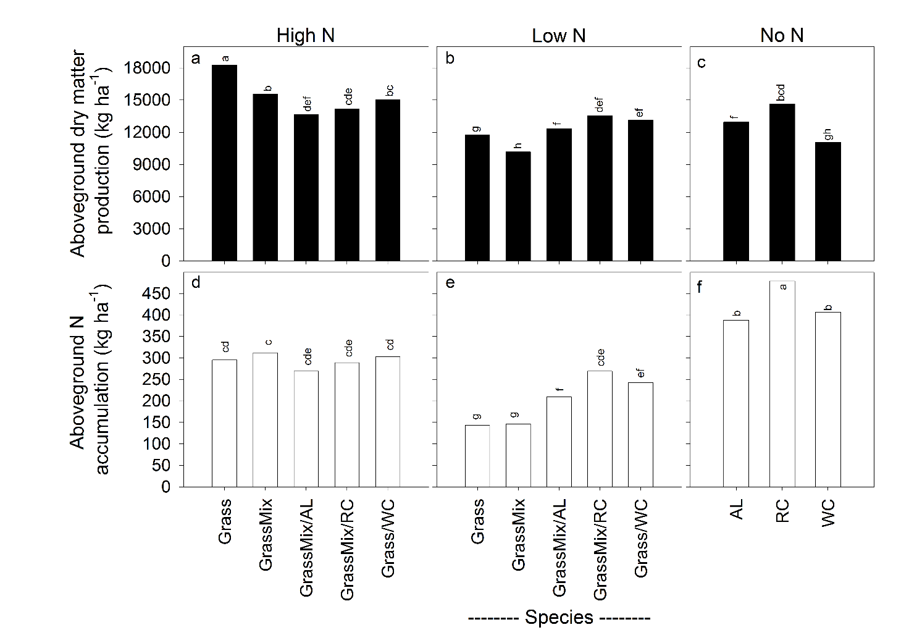

Figure 2
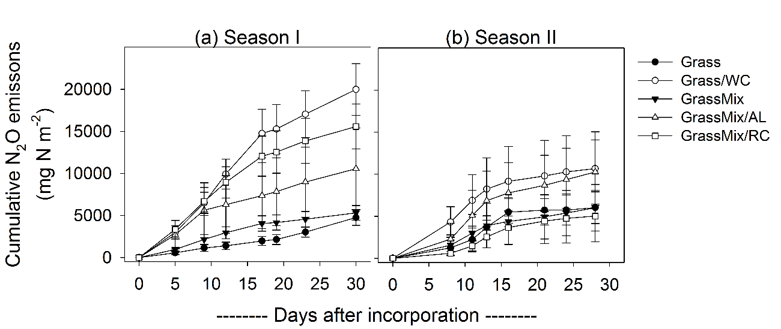
Figure 3
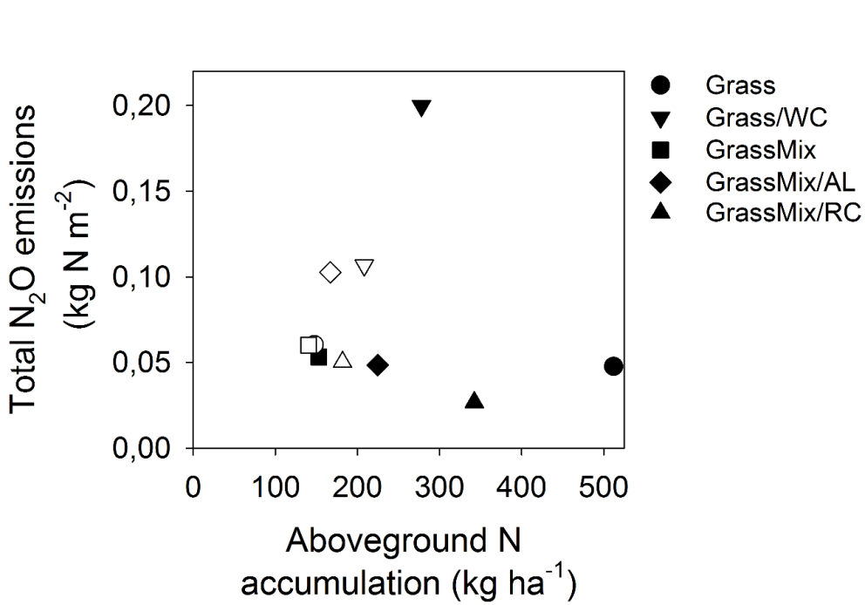

Figure 4
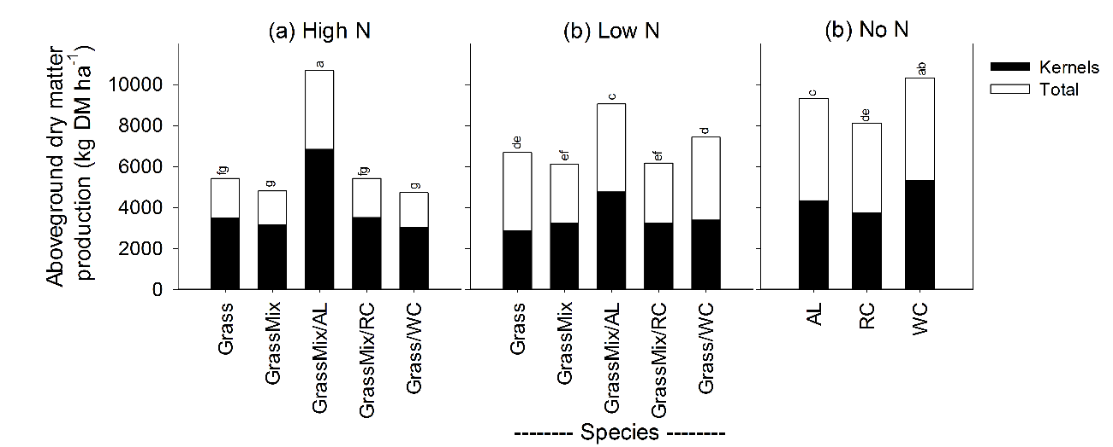

Figur 5
