A pyranose dehydrogenase-based biosensor for kinetic analysis of enzymatic hydrolysis of cellulose by cellulases

Nicolaj Cruys-Bagger^{1,2*}, Silke Flindt Badino¹, Radina Tokin¹, Mark Gontsarik¹, Samin Fathalinejad¹, Kenneth Jensen², Miguel Duarte Toscano², Trine Holst Sørensen^{1,2}, Kim Borch², Hirosuke Tatsumi³, Priit Väljamäe⁴ & Peter Westh^{1*}

- Research Unit for Biomaterials, NSM, Roskilde University, Universitetsvej 1, DK-4000 Roskilde, Denmark
- Novozymes A/S, Krogshøjvej 36, DK-2880 Bagsværd, Denmark
- Department of Chemistry, Faculty of Science, Shinshu University, Matsumoto, Nagano, 390-8621, Japan
- Institute of Molecular and Cell Biology, University of Tartu, Riia 23b – 202, 51010, Tartu, Estonia

* Corresponding authors: e-mail: nicolaj@ruc.dk / pwesth@ruc.dk
Research Unit for Functional Biomaterials, NSM, Roskilde University, Universitetsvej 1, 4000 Roskilde, Denmark, Telephone: (+45) 4674-3577
Research Unit for Functional Biomaterials, NSM, Roskilde University, Universitetsvej 1, 4000 Roskilde, Denmark, Telephone: (+45) 4674-2879 / Fax: (+45) 4674-3011

Highlights
- An electrochemical biosensor based on pyranose dehydrogenase was developed.
- The enzyme biosensor is not anomer specific.
- The enzyme biosensor showed high sensitivity and stability.
- The method can be used for real-time monitoring of cellulases activity on cellulose.

KEYWORDS: Pyranose dehydrogenase, biosensor, cellulase kinetics, Hypocrea jecorina, cellobiohydrolase, Cel6A
Abstract
A novel electrochemical enzyme biosensor was developed for real-time detection of cellulase activity when acting on their natural insoluble substrate, cellulose. The enzyme biosensor was constructed with Pyranose dehydrongease (PDH) from Agaricus meleagris that was immobilized on the surface of a carbon paste electrode, which contained the mediator 2,6-dichlorophenolindophenol (DCIP). An oxidation current of the reduced form of DCIP, DCIPH₂, produced by the PDH-catalyzed reaction with either glucose or cellobiose, was recorded under constant-potential amperometry at +0.25 V (vs. Ag/AgCl). The PDH-biosensor was shown to be anomer unspecific and it can therefore be used in kinetic studies over broad time-scales of both retaining- and inverting cellulases (in addition to enzyme cocktails). The biosensor was used for real-time measurements of the activity of the inverting cellobiohydrolase Cel6A from Hypocrea jecorina (HjCel6A) on cellulosic substrates with different morphology (bacterial microcrystalline cellulose (BMCC) and Avicel). The steady-state rate of hydrolysis increased towards a saturation plateau with increasing loads of substrate. The experimental results were rationalized using a steady-state rate equation for processive cellulases, and it was found that the turnover for HjCel6A at saturating substrate concentration (i.e. maximal apparent specific activity) was similar (0.39-0.40 s⁻¹) for the two substrates. Conversely, the substrate load at half-saturation was much lower for BMCC compared to Avicel. Biosensors covered with a polycarbonate membrane showed high operational stability of several weeks with daily use.

1. Introduction
A common observation in the kinetics of enzymatic cellulose degradation is a declining hydrolysis rate with both time and conversion [1, 2]. The origin of the slowdown remains unclear and both enzyme- and substrate related properties has been proposed [1, 3] and further progress in this area seems to require better descriptions of structural and kinetic aspects. Fundamental insights into the complex enzymatic hydrolysis process can be obtained from kinetic studies, but such work is challenged by the insoluble and heterogeneous nature of cellulose. Some progress has been obtained using novel real-time experimental approaches such as quartz crystal microbalance (QCM) measurements [4-8], electrochemical sensors [9] and isothermal titration calorimetry (ITC) [10-13]. Enzyme biosensors constitute another real-time approach, which in some cases provides advantageous sensitivity, specificity, and response time. This was utilized in the development of amperometric enzyme biosensors for cellulase activity based on immobilized enzymes including glucose oxidase (GOx), pyrroloquinoline quinine-dependent glucose dehydrogenase (GDH) or cellobiose dehydrogenase (CDH) [14-16]. The CDH biosensor was found to have a particularly high resolution in time and analyte concentration, and this allowed elucidation of the pre-steady state kinetics of the cellobiohydrolase Cel7A [17, 18] and endoglucanase Cel7B [16] from Hypocrea jecorina (anamorph: Trichoderma reesei) on their insoluble substrates. Sensors based on either GOx, GDH or CDH share the feature of specifically detecting the β-anomer of their analytes. In some special cases this specificity provides analytical advantages, but in general activity measurements, it sets up a number of severe limitations. Hence, these sensors cannot be directly used when the product of the enzymatic reaction is an α-anomer (e.g. for inverting cellulases such as Cel6A). More importantly, anomeric specificity limits the time-scales over which a biosensor can be used for any hydrolytic enzyme in real-time measurements. This is because mutarotation (i.e. equilibration of the α-β distribution) will occur in parallel with the enzymatic hydrolysis, and hence impede quantification of the product. In practice this means that the anomer-specific biosensors can be used over time-scales that are either much faster or much slower than the mutarotation because under these conditions mutarotation will either be negligible or fully equilibrated and hence easy to account for. Between these extremes there will be a broad interval where biosensor measurements will be either unfeasible or dependent on extensive and error-prone corrections [14]. In the light of this, a biosensor without anomeric specificity appears useful in attempts to elucidate cellulolytic enzymes and their ubiquitous activity loss.
Pyranose dehydrogenase (PDH, pyranose:acceptor oxidoreductase, EC 1.1.99.29) (PDH) is a glycosylated, extracellular, monomeric flavin-dependent sugar oxidoreductase secreted by several wood degrading fungi and a member of the glucose-methanol-choline oxidoreductase family [19, 20]. PDH from Agaricus meleagris (AmPDH) appears promising for biosensor-based cellulase activity studies because it shows a broad electron-donor substrate specificity which includes both mono-, di- and oligosaccharides, is inert towards oxygen, shows broad optimal pH range (pH 4-10) and is stable for months when stored at 4 °C [19, 21]. AmPDH can perform both single oxidizations on the C-1, C-2 or C-3 position or double oxidation (C-1,2 or C-3,4 positions) depending on the substrate and it is not specific to one of the anomeric forms [21]. AmPDH has been successfully “wired” with Osmium redox polymers and immobilized on electrodes both for detection of sugars [22, 23] and as anode in enzymatic biofuel cells [24-26].
In the present work a mediated amperometric biosensor based on immobilized AmPDH was developed and the biosensor was applied for real-time activity measurements of a cellulase hydrolyzing insoluble cellulose. The experimental results were analyzed with respect to a recent published steady-state rate equation for processive cellulases [27].

2. Methods and materials
2.1 Chemicals
Unless otherwise stated, all chemicals were of HPLC grade (> 99% purity) and supplied by Sigma-Aldrich (St. Louis, USA). α-D-(+)-glucose (> 99.0%) was supplied by Acros Organics (New Jersey, USA), β-D-(+)-glucose (> 99.0%) was from ChromaDex™ (Irvine, USA) and Cellotriose (Fine grade, >95%) was purchased from Seikagaku Biobusiness Corporation (Tokyo, Japan). All solutions were prepared with 50 mM sodium acetate and 2 mM CaCl₂ buffer adjusted to pH 5.0. Stock solutions of sugars were prepared at least 24 hrs before use to achieve mutarotative equilibrium except in the mutarotation test experiments where the solutions were prepared immediately before use.

2.2 Cellulose substrate preparations
Microcrystalline cellulose (Avicel PH-101) was from Fluka (Biochemika, Ireland). Bacterial microcrystalline cellulose (BMCC) was prepared by laboratory fermentation of Gluconobacter xylinum as described in detail elsewhere [28]. The cellulose suspensions were prepared in 50mM acetate buffer, pH 5.0 and added 0.01% sodium azide to prevent bacterial growth.

2.3 Enzyme production and purification
2.3.1 Pyranose dehydrogenase
Pyranose dehydrogenase from Agaricus meleagris was expressed, fermented and purified as described in the Supporting Information. The protein concentration was determined from absorbance measurement at 280 nm with the theoretical molar extinction coefficient (ε₂₈₀ = 67840 M⁻¹ cm⁻¹) derived from the amino acid sequence. The thermal stability was tested by differential scanning calorimetry (VP-DSC, MicroCal, USA) and a transition mid-point of 75.9 °C was measured.
2.2.3 Cel6A from Hypocrea jecorina
The inverting cellobiohydrolase, Cel6A, from Hypocrea jecorina (HjCel6A) was expressed, fermented and purified as described in the Supporting Information. The absence of cellobiase activity in the purified product was confirmed as lack of detectable activity against the chromogenic substrate analogue p-nitrophenyl-β-D- glucopyranoside (pNPG). The protein concentration was determined from absorbance measurement at 280 nm with the theoretical molar extinction coefficient (ε₂₈₀ = 96600 M⁻¹ cm⁻¹) derived from the amino acid sequence.

2.4 Preparation of enzyme-modified electrodes
Mediator-mixed carbon paste electrodes were prepared as described elsewhere [14, 17]. Four different mediators (1,4-benzoquinone (BQ), 2,6-dichloroindophenol (DCIP), ferricenium cation (Fc⁺) as the salt composed with hexafluorophosphate (PF₆⁻) or ferrocene (Fc)) was tested by adding a weighed amount (5-25 mg) of one mediator to graphite powder (100 mg) and liquid paraffin (35 µl). The mixture was thoroughly hand-mixed in an agate mortar until a homogenized paste was obtained. A portion of the resulting mediator-carbon paste was packed into carbon paste holders (Bioanalytical Systems, United Kingdom) with a working geometric area of 0.071cm² and the surface was polished using waxed weighing-paper. The enzyme modification of the electrode surface was carried out by by adding a 10-µL aliquot of a freshly prepared solution of a 1:1 mixture of AmPDH stock and 1% glutaraldehyde (glutaraldehyde solution, 25 % in H₂O) onto the polished electrode surface. The enzyme droplet was carefully smeared-out and allowed to evaporate at room temperature for 30 min. The electrodes were then stored at 4 °C in an inverted position in a closed vessel under humid condition. Enzyme cross-linking and immobilization was allowed to proceed overnight. The electrode surface was thoroughly rinsed with MQ-water and the PDH-biosensor was allowed to stabilize in the buffer between two to four hours and then in 1 mM glucose overnight at an applied potential sufficient to oxidize the mediator. Some PDH-biosensors were covered with a polycarbonate membrane with a pore-size of either 15 or 100 nm (Nuclepore polycarbonate Track Etch membrane Whatmann®, USA) and a nylon mesh with a Teflon-tube fitted over the membrane assembly to fixate them. Some of these were further drop-coated with 10 µL Nafion (0.5% v/v diluted in buffer) that was allowed to air dry for 30 min and stabilized in the buffer overnight before use.
A GOx-benzoquinone-carbon paste electrode was also prepared [29]. The procedure followed that described above with 10 mg benzoquinone mixed in the graphite paste and then glucose oxidase as the sensing enzyme. The glucose oxidase-biosensor was covered with a polycarbonate membrane with a pore-size of 15nm.

2.5 Electrochemical instrumentation and measurements
A conventional electrochemical setup employed the PDH-biosensor as the working electrode, an Ag│AgCl│3M NaCl electrode as the reference electrode (Bioanalytical Systems, United Kingdom) and a platinum coiled wire as auxiliary electrode. Cyclic voltammetry was carried out using a VersaSTAT 3F (Princeton Applied Research, Princeton, NJ). Amperometric measurements were carried out with type-1112 potentiostats from Husou Seisakusyo Co. (Kawasaki, Japan) which were connected to a computer via an Agilent 34401A DMM and a LabVIEW 2012 data acquisition software (National Instruments, Austin, Texas, USA). In the amperometric measurements calibrant- and enzyme solutions were delivered through a FEP tube (ID 0.15 mm) from a syringe (SGE Analytical Science) mounted in a syringe pump (Fusion 100, Chemyx, Stafford, USA). The syringe pump was controlled via the LabVIEW program . Calibrations were conducted by consecutive titrations of 5-20 µL aliquots of degassed cellobiose solution into buffer. All electrochemical measurements were performed in a water-jacketed glass-cell connected to a water bath (Julabo F12, Seelbach, Germany).

2.5.2 Test of mutarotation effect on PDH-biosensor response
The absence of a preference for one anomeric form was confirmed in trials on respectively α-glucose, β-glucose and β-cellobiose. Specifically the sugar solutions were freshly prepared in cold buffer, mixed for 60 sec and an aliquot titrated to the electrochemical cell with either the PDH- or GOx-biosensor. The response from the enzyme biosensors to an equilibrated glucose solution before and after the measurement was used to check the sensitivity of the sensors.

2.5.3 Enzymatic cellulose hydrolysis experiments
An AmPDH biosensor with the DCIP mediator covered with a 15nm pore-size polycarbonate membrane and used for detection of cellobiose released during enzymatic cellulose hydrolysis experiments. An applied potential of +0.25V was used as this was found to be the optimal detection potential for the PDH-DCIP-biosensor (see Results and discussion). Measurements were made on 5-mL degassed samples of the cellulose suspensions.

All experiments were conducted at 25.0 ± 0.1 °C and a magnetic stirrer at 500 rpm provided convective transport during the amperometric measurements. Data were collected at 1 s⁻¹.

3. Results and discussion
3.1. Optimization of PDH-biosensor
From the steady-state kinetic parameters of AmPDH with various electron acceptors reported by Sygmund et al. [19] Fc⁺, BQ and DCIP was tested for the development of a AmPDH biosensor. BQ has been widely used as mediator in amperometric enzyme biosensors [14-17, 29-32]. AmPDH biosensors prepared with BQ showed anodic current responses at an applied potential at + 0.5V. Ferrocene and its derivatives have also been used as mediators in second-generation enzyme biosensors [33, 34]. The PDH-biosensors prepared with Fc⁺ gave 75% higher anodic current response compared to DCIP (applied potential of Fc detection was +0.2 V). However, the PDH-biosensors prepared with both Fc⁺ and Fc were found not to give stable current responses at pH 5. This could be attributed to instability of the ferricenium ion in aqueous environments as it has been reported to undergoes hydrolysis [35]. DCIP is frequently used in enzyme assays in solution and as a pH/redox indicator. It is electrochemically active and has been used as a redox coupling agent in detection of NADH [36, 37] and in enzyme immunoassays [38-40]. DCIP has also been successfully used as mediator in enzyme biosensors with glucose dehydrogenase [41] and lactate oxidase [42]. The PDH-biosensors prepared with DCIP showed the best performance and this mediator was therefore selected for further biosensor optimization. Variations of DCIP dosage in the carbon paste showed that the optimal amount was between 10 and 20 mg to 100 mg graphite powder (data not shown).

3.2 Cyclic and hydrodynamic voltammetry of the PDH-DCIP-biosensor
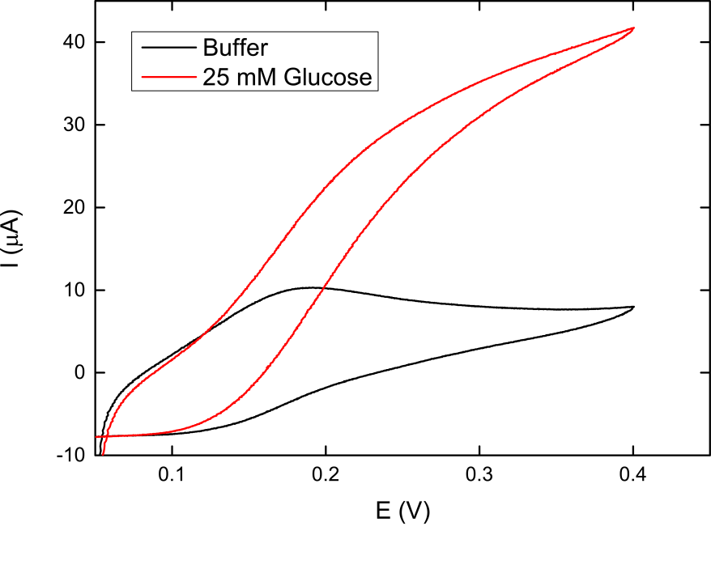
Figure 1. Cyclic voltammogram obtained with the PDH-DCIP-biosensor (no membrane) at 25 °C in buffer (black line) and buffer containing 25 mM glucose (red line). Scan rate: 1 mV s⁻¹. The potential was scanned from negative to positive. Buffer solution: 50mM sodium acetate, pH 5.0.

Cyclic voltammetry (CV) of DCIP shows two oxidation peaks at respectively +0.05-0.01V and +0.5V (vs. Ag/AgCl) [36, 43]. The two oxidizable groups are the 2,6-dichloro-4-hydroxyphenyl-imino group and the phenolic group (the structure of DCIP can be seen in Fig. 3). The cyclic voltammogram shows well-defined reduction and oxidation waves of the 2,6-dichloro-4-(hydroxyphenyl-imino/-quinone) group if the scan is stopped before +0.4V (pH 7.8)[44]. Oxidation of the phenolic ring occurs at a potential higher than +0.5 V and is irreversible. It has been suggested that the product of the second oxidation can lead to electropolymerization on the electrode surface, and hence cause electrode fouling [36]. CV was performed to characterize the bioelectrocatalysis properties of the PDH-DCIP-biosensor (non-membrane covered) in the potential range +0.05 to +0.4V. Results in Fig. 1 show that the PDH-DCIP-biosensor produces an anodic wave for the electrode reaction of reduced DCIP (DCIPH₂) when glucose is added to the buffer solution. This reflects the production of DCIPH₂ by the PDH-catalyzed reaction.
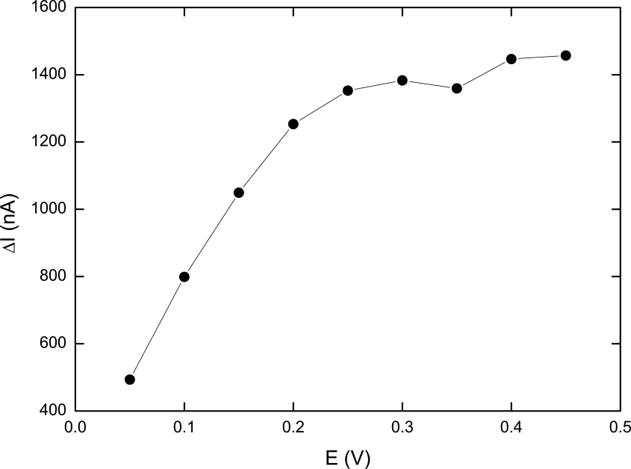
Figure 2. Hydrodynamic voltammogram of a Nafion-polycarbonate (15nm pore size) covered PDH-DCIP-biosensor. The amperometric response towards 1 mM glucose was recorded after a baseline was obtained. The applied potential was varied from +0.05 to 0.45 V (vs. Ag/AgCl) in steps of 0.05 V.

Hydrodynamic voltammetry was performed to find the optimal detection potential of the PDH-DCIP-biosensor. This was performed with a PDH-biosensor that was covered with a 15 nm pore-size polycarbonate membrane and drop-coated with a layer of Nafion. The hydrodynamic voltammogram of the PDH-DCIP-biosensor can be seen in Fig. 2 and it appears that that the anodic current increase from +0.05V to +0.25V, where a plateau was observed with only a small increase up to +0.45V. At still higher potentials (> +0.5V) the current response dropped. This was expected due to fouling of the electrode surface from electropolymerization of DCIP at high potentials [36]. The detection potential was therefore set to +0.25V in all subsequent measurements. This value is in line with the detection potentials of reduced DCIP used earlier [36, 39, 42]. The measuring principle of the PDH-biosensor with DCIP serving as mediator can be seen in Fig.3. As a control a DCIP- sensor without PDH immobilized was calibrated at +0.25V and did not give any anodic current response in the range 0.01 to 1 mM glucose (data not shown). It should be noted that reduced DCIP (DCIPH₂) can be re-oxidized by oxygen dissolved in the solution [36]. This reaction is slow, but in experiments running over long time, it could potentially influence the current response.
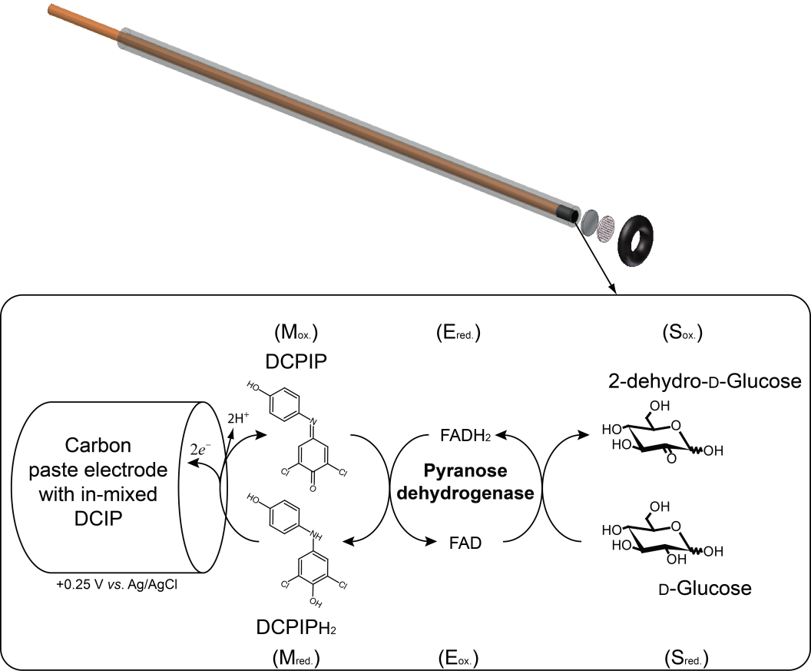
Figure 3. Schematic illustration of the mediated bioelectrocatalytic measuring principle for the amperometric pyranose dehydrogenase-biosensor with DCIP serving as mediator.

3.3 Calibration and analytical performance of the PDH-DCIP-biosensor
The current response of a polycarbonate-covered (100nm pore size) PDH-biosensor during successive additions of cellobiose at an applied potential of +0.25V (vs. Ag/AgCl) is shown in Fig. 4. Upon injection the anodic current reached a steady state response within 30 s. The amperometric current response for cellobiose was linear in the range from 10 to 100 µM (Fig. 4) with a sensitivity around 6 nA/µM (correlation coefficient of >0.999, n = 9). The detection limit was 0.3 µM (S/N=3). The PDH-biosensors that were not covered with a membrane had a reduced upper limit of the linear range (< 10 µM cellobiose). Sensors with a 15nm pore-size polycarbonate membrane showed a linear range up to 4 mM cellobiose with a sensitivity of 0.54 nA/µM and a response time of 45 sec. The PDH-DCIP-biosensors that were both covered with 15nm pore-size polycarbonate membrane and drop-coated with Nafion also gave highly stable responses with a lower detection limit around 12 µM glucose. However, these biosensors had a much slower response-time (> 120-150 sec) and also required longer time to give a stable background current (> 1 hr).
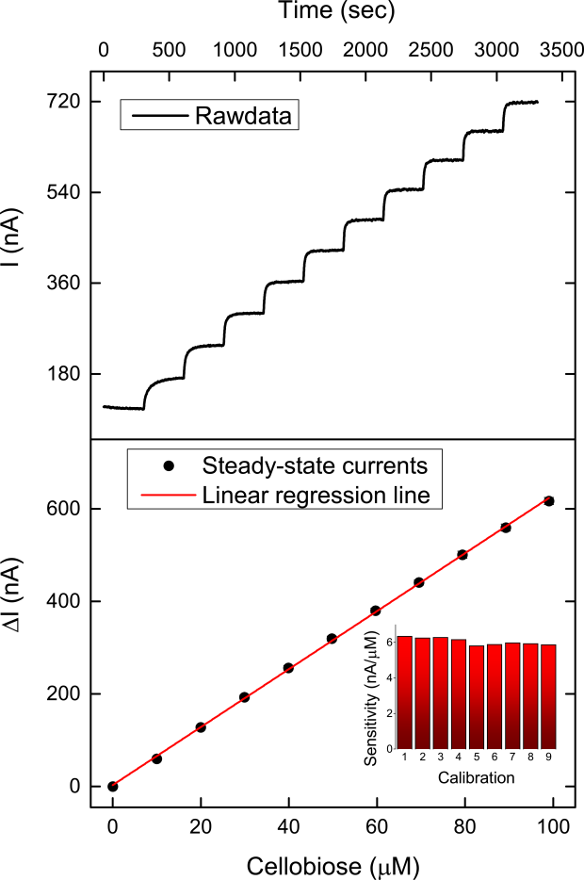
Figure 4. The upper panel shows the amperometric response of the polycarbonate(100nm) covered PDH-DCIP-biosensor to successive additions of cellobiose at 25 °C in 50 mM sodium acetate buffer, pH 5 (stirring rate 500 rpm). The applied potential was +0.25 V (vs. Ag/AgCl). The lower panel shows the calibration plot of the steady-state currents vs. the cellobiose concentration. The insert shows the performance stability in the form of the change in the sensitivity as a function of the calibration number. All calibrations were performed over two days where the biosensor was used in the enzymatic cellulose hydrolysis experiments shown in Fig. 6.

3.4 Mutarotation effect on PDH-biosensor response
Enzymatic hydrolysis of β-glycosidic bonds may proceed via two different acid/base-catalyzed mechanisms that results in either retention or inversion of the anomeric configuration of the product [45-47]. Subsequently, so-called mutarotation will shift the population of product towards the equilibrium distribution of the α- and β anomer at a rate that depends strongly on temperature and pH [48, 49]. One of the main purposes of the current work was to design a biosensor that was unaffected by this and to test if the PDH-DCIP response was indeed insensitive to mutarotation the temporal development in the signals from solutions that were initially 1 mM with respect to either α- D-glucose, β- D-glucose or β- D-cellobiose was measured. The results are shown in Fig. 5, together with a control experiment where 5 mM solutions of the α and β forms of glucose are monitored over time with a GOx-based electrode (see Methods and materials). It is clear that the PDH-DCIP sensor generates a time-independent signal in these tests while the GOx-sensor, which specifically senses the β−anomer, shows a gradual change towards a constant value. This provides strong experimental evidence that the PDH-biosensor exhibits the expected non-specificity (unlike the GOx-sensor) and hence that the new sensor can be used directly to monitor cellulase activity without any interference from mutarotation. This conclusion was further supported by comparisons with the signal from a CDH-sensor [14].
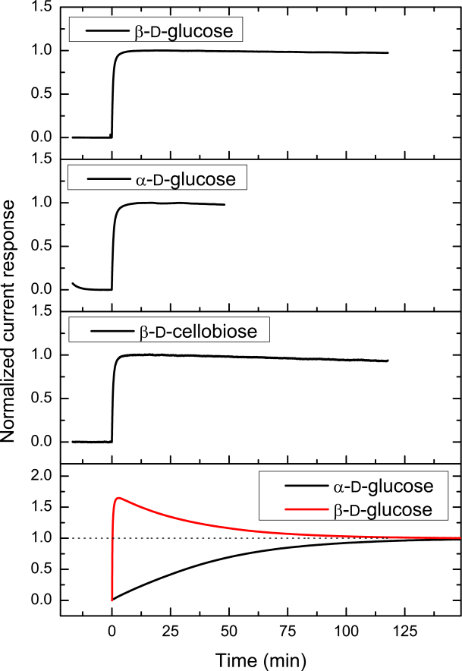
Figure 5. Mutarotation effect on the current response of the PDH-DCIP-biosensor. The normalized current response of 1 mM of β-D-glucose, α-D-glucose and β-D-cellobiose are shown. For comparison the last panel shows the normalized current response for a glucose oxidase-benzoquinone-carbon paste electrode to either 5 mM α- D-glucose or β- D-glucose (applied potential +0.6 V).

3.5 Application of the PDH-biosensor to real-time measurements of enzymatic hydrolysis of cellulose
A PDH-DCIP-biosensor covered with a 100 nm pore-size polycarbonate membrane was used for real-time measurements of the initial kinetics of the inverting cellobiohydrolase, HjCel6A. The sensor was calibrated against cellobiose, which is the major product of HjCel6A [50] . The results can be seen in Fig. 6. The left panels show the release of cellobiose from two different cellulosic substrates, BMCC and Avicel, when the dosage of cellulose is increased and the enzyme load is kept constant. The right panels in Fig. 6 show the steady state hydrolysis rate (the slope between 500 and 600 sec in the left panels) plotted as function of the substrate dosage. Results of a Michaelis-Menten-type analysis [27] of this data are shown in Tab.1. The two substrates differ in physical properties [2, 51] and this translates into the kinetic constants. Thus, while the turnover at saturating substrate load (k_{cat,app}) is similar for the two substrates, _{p}K_{M} was much lower for BMCC. This implies that the affinity of HjCel6A is higher for BMCC than for Avicel, and this observation may simply reflect that the accessible area per mass unit (and hence probably the number of binding sites) is much higher for BMCC compared to Avicel [52, 53].
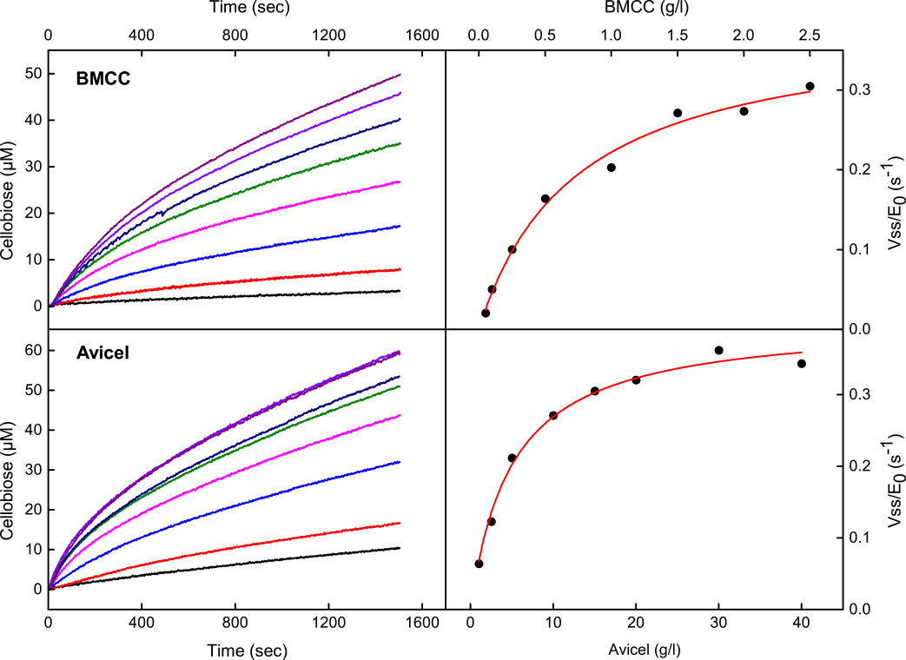
Figure 6. HjCel6A (0.1 µM) activity on cellulosic substrates with different surface morphology and crystallinity. The steady state rate was found by linear regression between 500-600 sec and plotted as function of the substrate load. The red line is the nonlinear regression to V_{SS}/E₀ = k_{cat,app}*S/(_{p}K_{M} + S).

Table 1. Kinetic parameters for HjCel6A acting on bacterial microcrystalline cellulose (BMCC) and Avicel. The parameters were found from analysis of the data in the right panels in Fig. 6 with respect to a Michaelis-Menten type equation for processive cellulases.
 | k_{cat,app} (s⁻¹) † | _{p}K_{M} (g/L) # | k_{cat,app} / _{p}K_{M} ((g/L)⁻¹ s⁻¹) ¤ | R²
BMCC | 0.386 | 0.74 | 0.52 | 0.9892
Avicel | 0.404 | 5.0 | 0.081 | 0.9891
† k_{cat,app} is the maximal apparent specific activity; i.e. the asymptotic value in the right panels in Fig. 6.
# _{p}K_{M} is the processive dissociation-constants
¤ substrate specificity

3.6 Operational stability and reproducibility of preparing the PDH-biosensors
The PDH-biosensors generally showed very good operational stability. The sensor covered with a 100nm pore-size polycarbonate membrane, for example, had a RSD% of 3.4 for the sensitivity over two days while in continuous use (insert in the lower panel in Fig. 4). Such a slow drop can readily be handled through regular calibrations. PDH-DCIP sensors could be produced quite uniformly, and the sensitivity for three sensors prepared in the same way varied 10 % (see Fig. 7). These PDH- biosensors had a RSD% of 17.4, 3.9 and 9.3 for the sensitivity over two-week period while in continuous use in enzymatic hydrolysis experiments.
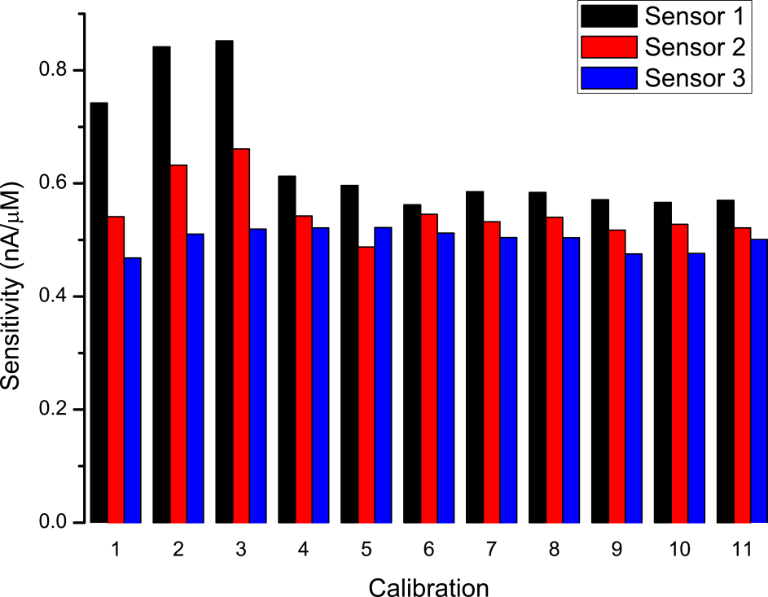
Figure 7. Change in the sensitivity for three Nafion-polycarbonate(15nm)-PDH-DCIP-biosensors over a two-week period with continuous use.

5. Conclusion
In conclusion, it has shown that a mediated amperometric biosensor using immobilized pyranose dehydrogenase from Agaricus meleagris on a carbon paste electrode and DCIP as mediator provides an advantageous approach to kinetic studies of cellulases. The PDH-biosensor is anomer unspecific and can therefore be used in continuous studies of both retaining- and inverting cellulases over different time-scales. The PDH-DCIP-biosensor showed high sensitivity and when covered with a polycarbonate membrane the stability was several weeks with daily use. The new sensor had a reasonable time resolution, which allowed steady-state recordings within tens of seconds, but it did not respond fast enough to capture transient enzyme kinetics as in the case of some CDH-sensors [14, 17]. The PDH-biosensor was used to measure the initial activity of the inverting cellobiohydrolase HjCel6A acting on its natural insoluble substrate, cellulose. For HjCel6A acting on substrates with different morphology the dependence of the steady-state rate on the amount of substrate could be rationalized by a steady-state equation for processive cellulases.
Abbreviations
AmPDH: Pyranose dehydrogenase from Agaricus meleagris
BQ: 1,4-Benzoquinone
Fc: Ferrocene
Fc⁺: Ferricenium ion
Fc⁺PF₆: ferricenium hexafluorophosphate
DCIP: 2,6-dichloroindophenol

Acknowledgments
This work was supported by the Danish Agency for Science, Technology and Innovation, Programme Commission on Sustainable Energy and Environment (grant # 2104-07-0028 to PW) and the Ministry of Education, Culture, Sports, Science and Technology in Japan (grant-in-aid for young scientists # 23760746 and special coordination funds for promoting science and technology to HT).

Conflict of interest statement
Novozymes is a enzyme producing company.

Appendix. Supplementary Information
Supplementary data associated with this article can be found in the online version.

References
[1] Mansfield SD, Mooney C, Saddler JN. Substrate and enzyme characteristics that limit cellulose hydrolysis. Biotechnol Prog. 1999;15:804-16.
[2] Zhang YHP, Lynd LR. Toward an aggregated understanding of enzymatic hydrolysis of cellulose: Noncomplexed cellulase systems. Biotechnol Bioeng. 2004;88:797-824.
[3] Yang B, Dai Z, Ding S, Wyman CE. Enzymatic hydrolysis of cellulosic biomass. Biofuels. 2011;2:421-50.
[4] Turon X, Rojas OJ, Deinhammer RS. Enzymatic kinetics of cellulose hydrolysis: A QCM-D study. Langmuir. 2008;24:3880-7.
[5] Maurer SA, Bedbrook CN, Radke CJ. Competitive Sorption Kinetics of Inhibited Endo- and Exoglucanases on a Model Cellulose Substrate. Langmuir. 2012;28:14598-608.
[6] Martin-Sampedro R, Rahikainen JL, Johansson L-S, Marjamaa K, Laine J, Kruus K, et al. Preferential Adsorption and Activity of Monocomponent Cellulases on Lignocellulose Thin Films with Varying Lignin Content. Biomacromolecules. 2013;14:1231-9.
[7] Suchy M, Linder MB, Tammelin T, Campbell JM, Vuorinen T, Kontturi E. Quantitative Assessment of the Enzymatic Degradation of Amorphous Cellulose by Using a Quartz Crystal Microbalance with Dissipation Monitoring. Langmuir. 2011;27:8819-28.
[8] Hu G, Heitmann JA, Rojas OJ. Quantification of Cellulase Activity Using the Quartz Crystal Microbalance Technique. Anal Chem. 2009;81:1872-80.
[9] Cruys-Bagger N, Tatsumi H, Borch K, Westh P. A graphene modified screen-printed carbon electrode for measurements of unoccupied active sites in a cellulase. Analytical Biochemistry. 2014;447:162-8.
[10] Murphy L, Baumann MJ, Borch K, Sweeney M, Westh P. An enzymatic signal amplification system for calorimetric studies of cellobiohydrolases. Analytical Biochemistry. 2010;404:140-8.
[11] Murphy L, Borch K, McFarland KC, Bohlin C, Westh P. A calorimetric assay for enzymatic saccharification of biomass. Enzyme and Microbial Technology. 2010;46:141-6.
[12] Olsen SN, Bohlin C, Murphy L, Borch K, McFarland KC, Sweeny MD, et al. Effects of non-ionic surfactants on the interactions between cellulases and tannic acid: A model system for cellulase-poly-phenol interactions. Enzyme and Microbial Technology. 2011;49:353-9.
[13] Murphy L, Bohlin C, Baumann MJ, Olsen SN, Sorensen TH, Anderson L, et al. Product inhibition of five Hypocrea jecorina cellulases. Enzyme and Microbial Technology. 2013;52:163-9.
[14] Cruys-Bagger N, Ren G, Tatsumi H, Baumann MJ, Spodsberg N, Andersen HD, et al. An amperometric enzyme biosensor for real-time measurements of cellobiohydrolase activity on insoluble cellulose. Biotechnol Bioeng. 2012;109:3199-204.
[15] Tatsumi H, Katano H, Ikeda T. Kinetic analysis of enzymatic hydrolysis of crystalline cellulose by cellobiohydrolase using an amperometric biosensor. Analytical Biochemistry. 2006;357:257-61.
[16] Murphy L, Cruys-Bagger N, Damgaard HD, Baumann MJ, Olsen SN, Borch K, et al. Origin of Initial Burst in Activity for Trichoderma reesei endo-Glucanases Hydrolyzing Insoluble Cellulose. J Biol Chem. 2012;287:1252-60.
[17] Cruys-Bagger N, Elmerdahl J, Praestgaard E, Tatsumi H, Spodsberg N, Borch K, et al. Pre-steady-state Kinetics for Hydrolysis of Insoluble Cellulose by Cellobiohydrolase Cel7A. J Biol Chem. 2012;287:18451-8.
[18] Cruys-Bagger N, Tatsumi H, Ren G, Borch K, Westh P. Transient kinetics and rate limiting steps for the processive cellobiohydrolase Cel7A: Effects of substrate structure and carbohydrate binding domain. Biochemistry. 2013;52:8938−48.
[19] Sygmund C, Kittl R, Volc J, Halada P, Kubatova E, Haltrich D, et al. Characterization of pyranose dehydrogenase from Agaricus meleagris and its application in the C-2 specific conversion of D-galactose. Journal of Biotechnology. 2008;133:334-42.
[20] Kittl R, Sygmund C, Halada P, Volc J, Divne C, Haltrich D, et al. Molecular cloning of three pyranose dehydrogenase-encoding genes from Agaricus meleagris and analysis of their expression by real-time RT-PCR. Current Genetics. 2008;53:117-27.
[21] Sedmera P, Halada P, Kubatova E, Haltrich D, Prikrylova V, Volc J. New biotransformations of some reducing sugars to the corresponding (di)dehydro(glycosyl) aldoses or aldonic acids using fungal pyranose dehydrogenase. J Mol Catal B-Enzym. 2006;41:32-42.
[22] Tasca F, Timur S, Ludwig R, Haltrich D, Volc J, Antiochia R, et al. Amperometric biosensors for detection of sugars based on the electrical wiring of different pyranose oxidases and pyranose dehydrogenases with osmium redox polymer on graphite electrodes. Electroanalysis. 2007;19:294-302.
[23] Yakovleva ME, Killyeni A, Ortiz R, Schulz C, MacAodha D, Conghaile PO, et al. Recombinant pyranose dehydrogenase-A versatile enzyme possessing both mediated and direct electron transfer. Electrochemistry Communications. 2012;24:120-2.
[24] Tasca F, Gorton L, Kujawa M, Patel I, Harreither W, Peterbauer CK, et al. Increasing the coulombic efficiency of glucose biofuel cell anodes by combination of redox enzymes. Biosens Bioelectron. 2010;25:1710-6.
[25] Minling S, Zafar MN, Sygmund C, Guschin DA, Ludwig R, Peterbauer CK, et al. Mutual enhancement of the current density and the coulombic efficiency for a bioanode by entrapping bi-enzymes with Os-complex modified electrodeposition paints. Biosens Bioelectron. 2013;40:308-14.
[26] Shao M, Zafar MN, Falk M, Ludwig R, Sygmund C, Peterbauer CK, et al. Optimization of a membraneless glucose/oxygen enzymatic fuel cell based on a bioanode with high coulombic efficiency and current density. Chemphyschem : a European journal of chemical physics and physical chemistry. 2013;14:2260-9.
[27] Cruys-Bagger N, Elmerdahl J, Praestgaard E, Borch K, Westh P. A steady state theory for processive cellulases. FEBS Journal. 2013;280:3952-61.
[28] Velleste R, Teugjas H, Väljamäe P. Reducing end-specific fluorescence labeled celluloses for cellulase mode of action. Cellulose. 2010;17:125-38.
[29] Tatsumi H, Katano H. Kinetics of the surface hydrolysis of raw starch by glucoamylase. Journal of Agricultural and Food Chemistry. 2005;53:8123-7.
[30] Tatsumi H, Katano H, Ikeda T. Activity Measurements of Chitosanase by an Amperometric Biosensor. Analytical Sciences - The Japan Society for Analytical Chemistry. 2009;25:825-7.
[31] Ikeda T, Hamada H, Miki K, Senda M. Glucose-oxidase immobilized benzoquinone carbon paste electrode as a glucose sensor. Agricultural and Biological Chemistry. 1985;49:541-3.
[32] Ikeda T, Hamada H, Senda M. Electrocatalytic oxidation of glucose at a glucose oxidase-immobilized benzoquinone mixed carbon paste electrode. Agricultural and Biological Chemistry. 1986;50:883-90.
[33] Cass AEG, Davis G, Francis GD, Hill HAO, Aston WJ, Higgins IJ, et al. Ferrocene-Mediated Enzyme Electrode for Amperometric Determination of Glucose. Anal Chem. 1984;56:667-71.
[34] Wang J, Wu LH, Lu ZL, Li RL, Sanchez J. Mixed ferrocene glucose-oxidase carbon paste electrode for amperometric determination of glucose. Anal Chim Acta. 1990;228:251-7.
[35] Yeh P, Kuwana T. Electrochemistry of micelle-solubilized ferrocene. Journal of the Electrochemical Society. 1976;123:1334-9.
[36] Tang HT, Hajizadeh K, Halsall HB, Heineman WR. Flow-injection analysis with electrochemical detection of reduced nicotinamide adenine-dinucleotide using 2,6-dichloroindophenol as a redox coupling agent. Analytical Biochemistry. 1991;192:243-50.
[37] Dicu D, Munteanu FD, Popeseu IC, Gorton L. Indophenol and O-quinone derivatives immobilized on zirconium phosphate for NADH electro-oxidation. Analytical Letters. 2003;36:1755-79.
[38] Tang HT, Halsall HB, Heineman WR. Electrochemical enzyme-immunoassay for phenytoin by flow-injection analysis incorporating a redox coupling agent. Clinical Chemistry. 1991;37:245-8.
[39] Yao H, Halsall HB, Heineman WR, Jenkins SH. Electrochemical dehydrogenase-based homogeneous assays in whole-blood. Clinical Chemistry. 1995;41:591-8.
[40] Barlag RE, Halsall HB, Heineman WR. Amperometric homogeneous competitive immunoassay in a perfluorocarbon emulsion oxygen therapeutic (PEOT). Anal Bioanal Chem. 2013;405:3541-7.
[41] Mullen WH, Churchouse SJ, Vadgama PM. Enzyme electrode for glucose based on the quinoprotein glucose-dehydrogenase. Analyst. 1985;110:925-8.
[42] Hirano K, Yamato H, Kunimoto K, Ohwa M. Design of novel electron transfer mediators based on indophenol derivatives for lactate sensor. Biosens Bioelectron. 2002;17:315-22.
[43] Hassan RYA, Bilitewski U. A viability assay for Candida albicans based on the electron transfer mediator 2,6-dichlorophenolindophenol. Analytical Biochemistry. 2011;419:26-32.
[44] Barlag RE, Halsall HB, Heineman WR. Cyclic voltammetry in a perfluorocarbon emulsion blood substitute. Electroanalysis. 2007;19:1139-44.
[45] Davies G, Henrissat B. Structures and Mechanisms of Glycosyl Hydrolases. Structure. 1995;3:853-9.
[46] McCarter JD, Withers SG. Mechanisms of Enzymatic Glycoside Hydrolysis. Curr Opin Struct Biol. 1994;4:885-92.
[47] Withers SG. Mechanisms of glycosyl transferases and hydrolases. Carbohydrate Polymers. 2001;44:325-37.
[48] Kabayama MA, Patterson D. The thermodynamics of mutarotation of some sugars 1. measurement of the heat of mutarotation by microcalorimetry. Canadian Journal of Chemistry. 1958;33:557-62.
[49] Kendrew JC, Moelwyn-Hughes EA. The kinetics of mutarotation in solution. Proceedings of the Royal Society of London Series a-Mathematical and Physical Sciences. 1940;176:0352-67.
[50] Koivula A, Kinnari T, Harjunpaa V, Ruohonen L, Teleman A, Drakenberg T, et al. Tryptophan 272: an essential determinant of crystalline cellulose degradation by Trichoderma reesei cellobiohydrolase Cel6A. FEBS Lett. 1998;429:341-6.
[51] Zhang YHP, Himmel ME, Mielenz JR. Outlook for cellulase improvement: Screening and selection strategies. Biotechnol Adv. 2006;24:452.
[52] Hong J, Ye X, Zhang YHP. Quantitative determination of cellulose accessibility to cellulase based on adsorption of a nonhydrolytic fusion protein containing CBM and GFP with its applications. Langmuir. 2007;23:12535-40.
[53] Jalak J, Väljamäe P. Mechanism of Initial Rapid Rate Retardation in Cellobiohydrolase Catalyzed Cellulose Hydrolysis. Biotechnol Bioeng. 2010;106:871-83.

