A graphene screen-printed carbon electrode for real-time measurements of unoccupied active sites in a cellulase
Nicolaj Cruys-Bagger#,†*, Hirosuke Tatsumi‡, Kim Borch† & Peter Westh#*

Short title: Assay for free active sites in a cellulase
Subject category: Enzymatic Assays and Analyses

# Research Unit for Biomaterials, NSM, Roskilde University, Universitetsvej 1, DK-4000 Roskilde, Denmark
† Novozymes A/S, Krogshøjvej 36, DK-2880 Bagsværd, Denmark
‡ Department of Chemistry, Faculty of Science, Shinshu University, Matsumoto, Nagano, 390-8621, Japan

* Corresponding authors
E-mail: nicolaj@ruc.dk / pwesth@ruc.dk

Present Addresses
Research Unit for Functional Biomaterials, NSM, Roskilde University, Universitetsvej 1, 4000 Roskilde, Denmark, Telephone: (+45) 4674-3577
Research Unit for Functional Biomaterials, NSM, Roskilde University, Universitetsvej 1, 4000 Roskilde, Denmark, Telephone: (+45) 4674-2879 / Fax: (+45) 4674-3011

KEYWORDS: Cellulase kinetics, Hypocrea jecorina Cel7A, cellobiohydrolase, screen-printed carbon electrodes, graphene, nitrophenol

ABSTRACT
Cellulases hydrolyze cellulose to soluble sugars and this process is utilized in sustainable industries based on lignocellulosic feedstock. Better analytical tools will be necessary to understand basic cellulase mechanisms, and hence deliver rational improvements of the industrial process. In this work we describe a new electrochemical approach to the quantification of the populations of enzyme that are respectively free in the aqueous bulk, adsorbed to the insoluble substrate with an unoccupied active site or threaded with the cellulose strand in the active tunnel. Distinction of these three states appears essential to the idetification of the rate limiting step. The method is based on disposable graphene modified screen-printed carbon electrodes, and we show how the temporal development in the concentrations of the three enzyme forms can be derived from a combination of the electrochemical data and adsorption measuments. The approach was tested for the cellobiohydrolase Cel7A from Hypocrea jecorina acting on microcrystalline cellulose, and it was found that the threaded enzyme form dominates for this system while adsorbed enzyme with an unoccupied active site constitutes less than 5% of the population.

INTRODUCTION
Interest in cellulolytic enzymes has intensified as a result of their role in upcoming sustainable industries producing biofuels and chemicals from lignocellulosic feedstock. Nevertheless, key aspects of cellulase action remain poorly understood, and this is at least in part the result of elusive interactions of the multi-domain enzymes and their heterogenous, insoluble substrate. Deeper understanding of these dynamic interactions appears necessary for the identification of rate-limiting steps, and, in turn, the development of better industrial enzymes through rational enzyme engineering.[1] Recent work has suggested that the recognition and association of a segment of the cellulose strand into the active site of the cellulase limits the rate of hydrolysis for crystalline cellulose.[2; 3; 4; 5] It follows that improvements of this “threading”-step of the cellulase could be a promising strategy for cellulase engineering.[2] However, other results have pointed towards slow dissociation of different types of enzyme-substrate complexes as the rate-limiting step.[6; 7; 8; 9; 10] In the light of this it appears that better understanding of basic cellulase mechanisms will require both improved analytical techniques, which can detect and quantify the different states of enzyme that occur in the catalytic cycle and better theoretical tools to rationalize the experimental data. In particular, such information is essential in attempts to model the complex course of events in enzymatic hydrolysis of cellulose. In the current work we suggest one such approach, which allows quantification the three enzyme states (free, associated and threaded) defined in Figure 1. Quantitative knowledge of the temporal development of these three states is essential for assessment of the putative rate limiting steps mentioned above. This type of information is, of course, primarily relevant for the fundamental understanding of the complex process, but it could also pave the way for knowledge-based solution to some of the countless challenges that has to be solved to implement industrial saccharification of biomass; in particular the development of improved enzyme variants. In our discussion of the three states in Figure 1 we will use the term “associated” for bound enzyme (i.e. enzyme that is removed from solution by filtration or centrifugation) which has a free active site (i.e. the catalytic residues are not blocked by a cellulose molecule). We will use the term “adsorbed” for any enzyme that is not free (i.e. the sum of associated and threaded enzyme in Figure 1). Experimental concentrations of these states are derived from the combined use of adsorption measurements and a novel continuous electrochemical method based on a graphene modified screen-printed carbon electrode (SPCE).
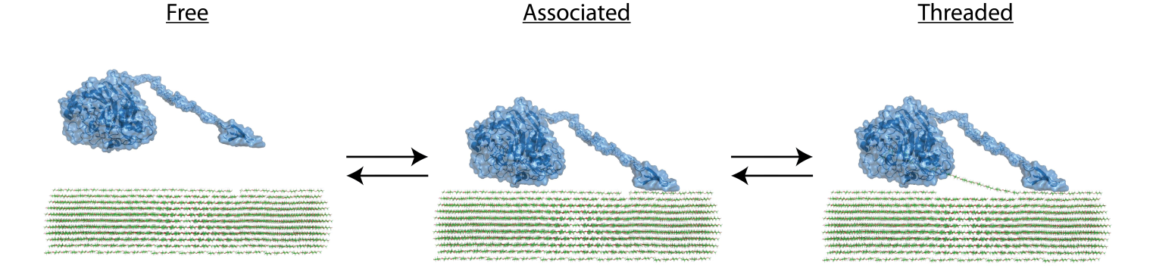
Figure 1. Definition of the three molecular states of a cellulase discussed in this work. The free enzyme in the aqueous bulk becomes adsorbed through binding of the cellulose binding module (CBM). Subsequently the cellulose strand is threaded into the active tunnel to form an activated complex.
Recent progress in experimental methods to determine the different molecular states of adsorbed cellulases includes the use of surface sensitive techniques such as quartz crystal microgravimetry [11] and flow-ellipsometry [5]. In these works, the separation of the adsorption- and hydrolysis processes, and hence threaded and non-threaded cellulase, relied on measurements with and without glucose added in concentrations that were claimed to inhibit activity but not binding. Other approaches have included batch measurements based on inhibition by a soluble competitor. Kostylev et al. [12], for example, used inhibition by cellotetraose to show that the processive endocellulase Cel9A from Thermobifida fusca, was predominantly in the associated sate (c.f. Figure 1) when added to a suspension of crystalline cellulose. The distribution between the states in Figure 1 has also been analyzed using synthetic soluble substrates which release either chromogenic or fluorogenic products such as p-nitrophenol and 4-methylumbelliferone.[13; 14; 15] If a sample contains both insoluble cellulose and one of these synthetic analogues, the specific inhibition exerted by cellulose on the hydrolysis of the soluble ‘reporter’ substrate allows distinction of threaded enzyme (which is unable to hydrolyze the reporter substrate) and enzyme with an accessible active site (i.e. the sum of free and associated populations in Figure 1).[8; 9] This approach was used to quantify the threaded concentration of the cellobiohydrolases Cel7A from Hypocrea jecorina and Cel7D from Phanerochaete chrysosporium on different cellulose substrates.[8] This work used quenching at different time-points followed by spectrophotometric quantification. Here, we report an electrochemical approach which allows continuous measurements and about two orders of magnitude higher sensitivity than spectrophotometry.

EXPERIMENTAL
Materials and Reagents. Unless otherwise stated, all chemicals were of HPLC grade (> 99% purity) and supplied by Sigma-Aldrich (St. Louis, MO, USA). All solutions were prepared with 50 mM sodium acetate buffer supplemented with 0.1M KCl and adjusted to pH 5.0 with 1 M HCl. Stock solutions of p-nitrophenyl β-D-lactopyranoside (pNPL), p-nitrophenol (pNP), p-aminophenyl β-D-cellobioside (pAPC, supplied from Santa Cruz Biotechnology (Heidelberg, Germany)), p-aminophenyl β-D- lactopyranoside (pAPL) (prepared by catalytic hydrogenation of 0.5mM pNPL in the standard buffer using 10% Pd on activated charcoal as a catalyst.), p-aminophenol (pAP), 4-methylumbelliferyl β–D-cellobioside (MUC) and 4-methylumbelliferone (MU) were prepared in the buffer and stored in aliquots at -30 °C. Solutions were prepared daily by dilution of thawed stock aliquots. The retaining cellobiohydrolase, Cel7A, from Hypocrea jecorina (anamorph: Trichoderma reesei) (HjCel7A) was cloned, expressed and purified as described elsewhere.[16; 17]
Electrodes. Screen-printed carbon electrodes (SPCEs) were purchased from DropSens (Oviedo, Spain). Four different types of SCPEs were tested. These were made of carbon either unmodified (DRP-C100), multi-walled carbon nanotube modified (DRP-110CNT), single-walled carbon nanotube modified (DRP-SWCNT) or graphene modified (DRP-110GPH), respectively. The planar SPCEs consists of a conventional three-electrode configuration with a silver pseudo-reference electrode and a carbon counter electrode printed on a ceramic support with the dimensions of 3.3 x 1.0 x 0.05 cm (length x width x height). The working carbon electrode has a diameter of 4 mm (geometric surface area of 12.57 mm²). The carbon nanotubes on the MWCNT-SPCE and SWCNT-SPCE were grown by chemical vapor deposition (CVD) process and functionalized with approximately a 5% ratio of carboxylic groups. Further information of the different SPCEs can be found at the supplier’s website (http://www.dropsens.com/). The SPCEs were connected to the potentiostats through a specific connector from DropSens. In addition to the screen printed electrodes we also tested a number of normal disk-type carbon based electrodes including glassy carbon, carbon paste, plastic formed carbon as well as basal- and edge-plane pyrolytic graphite.
Electrochemical Measurements. A VersaSTAT 3F from Princeton Applied Research (Tennessee, US) or a HECS 972 potentiostat from Husou Seisakusyo Co. (Kawasaki, Japan) was used for cyclic voltammetry. The HECS 972 were connected to a computer via GPIB-interface and controlled with a home-written C++ program. Constant-potential amperometry was performed with a 1112 potentiostat from Husou Seisakusyo Co., which was connected to a computer via a Agilent 34401A DMM and a AD/DA converter with a data acquisition program written in LabVIEW 2012 (National Instruments, Austin, USA). Electrochemical measurements were performed in 10 ml solution in a water-jacketed glass-cell connected to a water bath. All applied potentials are specified with respect to the internal Ag-pseudo reference electrode of the SPCEs (55.5mV vs. SCE (Bioanalytical Systems, UK) in the buffer). Prior to all measurement the SPCEs were pre-treated by cycling the potential 10 times between +0.1 and +1.1V with a scan rate of 50 mV s⁻¹ in the buffer. The SPCEs were electrochemically characterized by cyclic voltammetry in 1 mM aqueous solution of the outer-sphere one-electron redox probe potassium ferricyanide in 0.1 M KCl. Cyclic voltamograms were recorded by cycling the potential between +0.1 and +1.1 V with a scan rate of 50 mV s⁻¹ in 1 mM pNP solution. In the amperometric measurements the solution was stirred by a magnetic bar (20x3 mm) at 500 rpm.
Electrochemical Enzyme Assay. Calibrant (pNP, pAP or MU solution) or enzyme solution were delivered to the reaction vessel from a 100-µL syringe (SGE Analytical Science, Melbourne, Victoria, Australia) mounted in a syringe pump (Fusion 100, Chemyx, Stafford, TX) through 0.125 mm ID PEEK tubing. Calibration experiments were conducted by consecutive titrations of 1–5 µL aliquots of calibrant solution into pure buffer. A graphene modified SPCE (GPH-SPCE) and pNPL was used in the hydrolysis experiments to measure the free active site concentration of HjCel7A. The GPH-SPCE was pretreated by scanning 20 times from +0.1 to +1.1 V first in buffer and then in 1mM pNP solution. The GPH-SPCE was further stabilized at +1.0 V for two hours in 0.1 mM pNP solution. The activity of 20-100 nM HjCel7A against 0.5mM pNPL was measured amperometrically with the GPH-SPEC poised at +1.0 V. When the background was stable HjCel7A was injected over 1.0 s (irrespectively of the injection volume). Data were collected at 0.2 s⁻¹ and all hydrolysis data were corrected for the background current and the injection-time. Calibration against pNP was conducted between each experiment to account for any decrease in sensitivity of the GPH-SPCE. The current signal was converted to the corresponding pNP concentration from the calibration experiment, and the slope, i.e. rate of pNPL hydrolysis, of this plot provides a measure of the HjCel7A concentration with free active site (i.e. free and associated enzyme in Figure 1).
Adsorption experiments. The adsorption kinetics of HjCel7A (100 nM) to Avicel was measured in 100 ml samples stirred at 500 rpm. Upon addition of the enzyme, 2 ml samples were retrieved at different times. The 2 ml were immediately transferred to a centrifuge and spun at 14500 RPM (7000g) for 30 sec. The intrinsic enzyme fluorescence on the supernatant (λ_{ex}/λ_{em} = 280/345 nm) was determined with a Shimadzu Spectrofluorophotometer (RF-5301PC) and converted to the concentration of free enzyme on the basis of a separate standard curve (10-100 nM HjCel7A). The adsorption experiments were performed in triplicate.
All experiments were conducted at 25.0 ± 0.1 °C. Data were analyzed in OriginPro 9.0 (OriginLab, Northampton, MA, USA).

RESULTS AND DISCUSSION
Development of electrochemical assay. Tests of four artificial substrates (pNPL, MUC, pAPC and pAPL) with electrochemical active products (pNP, MU and pAP) showed that pNPL was the most applicable as pAPC and pAPL was not hydrolyzed sufficiently by HjCel7A and MU showed electrode fouling as pNP – see below. (For the electrochemical characterization of the electrochemical products see Supporting Information). Hence, pNPL was used as soluble substrate in all subsequent work. The product pNP can be quantified by both amperometric and voltammetric techniques. The former approach shows advantages including low detection limits and the option of real-time measurements. However, the challenge of anodic detection of pNP is fouling of the electrode surface by the oxidation product [18; 19; 20]. Carbon nanotube-modified glassy carbon electrodes have shown to enhance the stability and minimize fouling of anodic detection of phenolic compounds [19] including pNP [20]. Graphene modified electrodes have also shown resistance towards electrode fouling of oxidation reaction products of e.g. NADH [21] and pNP [22]. We used cyclic voltammetry to monitor the resistance to fouling by pNP for a number of different electrodes including both screen printed and disk-type electrodes as specified above.
Repetitive cyclic voltammograms for 1 mM pNP solution of the different SPCEs can be seen in Figure 2. The current signal of the SPCE and MWCNT-SPCE shows a rapid decrease in the anodic peak current upon repetitive scans and completely disappears after a few scans. On the other hand the SWCNT-SPCE shows some resistance to electrode fouling but the anodic peak is completely disappeared after 10 repetitive scans. In contrast Figure 2 clearly shows that the GPH-SPCE is far superior to electrode fouling compared to all other tested electrodes in this respect. (Normal disk-type carbon electrodes were also tested, see Figure S-3). Thus, even after 20 scans the anodic peak current of a graphene modified SPCE was still 70% of the initial value. All further experiments were conducted with the GPH-SPCE.

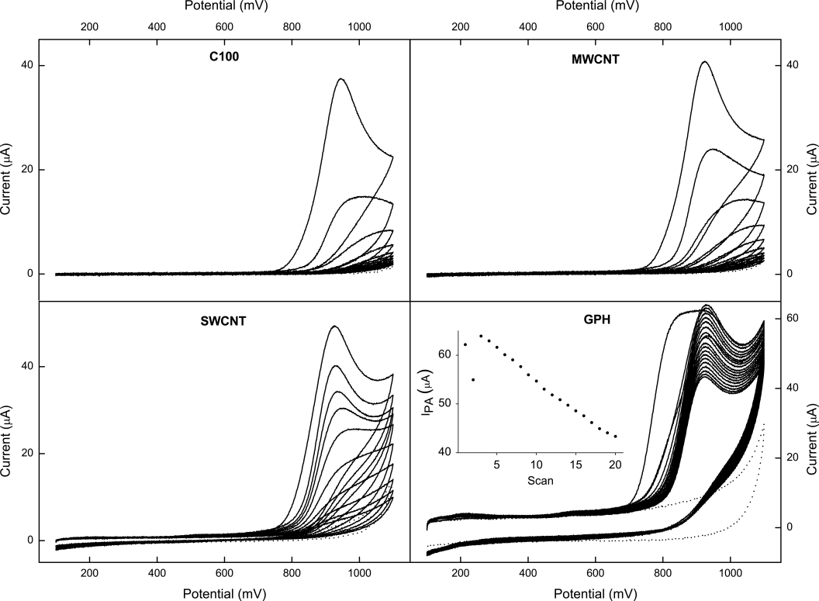
Figure 2. Repetitive cyclic voltammograms for 1 mM pNP solution of the different SPCEs. Scan rate: 50 mV s⁻¹. The insert in GPH shows the anodic peak current (I_{pa}) as a function of the scan number.

We used hydrodynamic voltammetry to determine the optimal applied potential for pNP detection. Results in Figure S-2 (supplementary material) shows that a potential of +1.0 V (measured vs. the internal Ag-reference) offered the best signal-to-noise ratio and stability, and we used this setting in all subsequent measurements. Calibration data for pNP is shown in Figure 3, and it appears that the response is stable and scales proportionally to the concentration of analyte. The insert in the upper panel in Figure 3 illustrates the time resolution of the electrode. It was generally found that 95% of the steady state signal was reached in about 5 sec (t_{95%} ~ 5 sec). The average gain factor (sensitivity) for all calibrations carried out in conjunction with the hydrolysis experiments shown in Figure 4 and 5 was 3.6 ± 0.5 nA µM⁻¹. Each of these calibrations was based on 10 pNP concentrations and each linear fit had R² >0.9998. Results for individual calibrations are illustrated in the histogram in the insert in the lower panel of Figure 3. Based on this, the detection limit (defined as 3σ) is about 50 nM and the upper limit for linear response above 10 µM. The detection limit is about two orders of magnitude better that for spectrophotometry, which is conventionally used to quantify pNP.

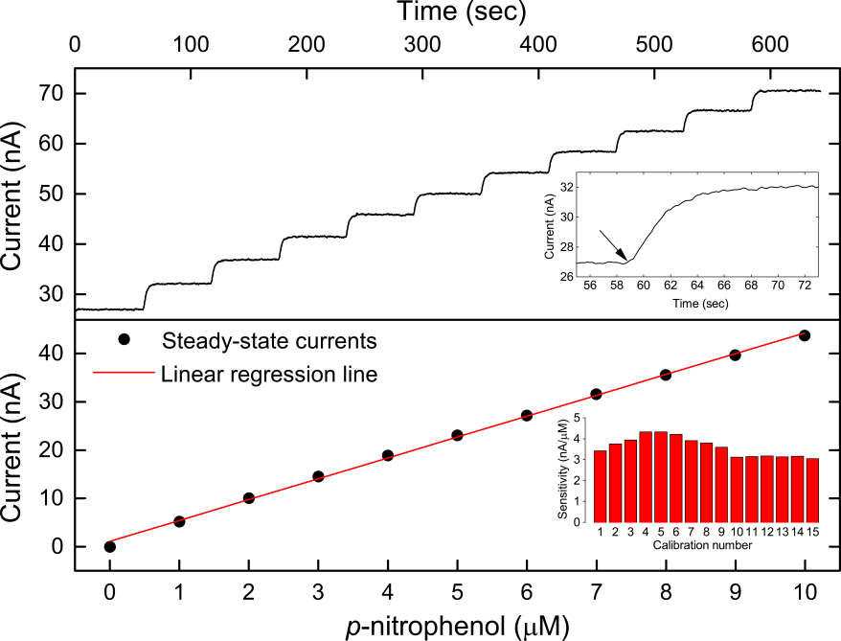
Figure 3. Calibration of the graphene modified SPCE with pNP. The upper panel shows a typical amperometric (current vs. time) response curve for successive titrations of pNP. The insert in the upper panel shows the enlargement of the response after the first injection. The arrow marks the injection of 1 μM pNP (final concentration). The lower panel shows the steady-state currents and regression line plotted against the pNP concentration. The insert in the lower panel shows the variation in the sensitivity, i.e. slopes, for 10-point calibration experiments performed during all of the enzymatic hydrolysis experiments conducted in the article.

Development of cellulase assay. We want to use the GPH-SPCE to estimate the concentration of cellulase with accessible active site (i.e. the sum of the free and associated populations in Figure 1) as illustrated in the upper panel in Figure 4. This can be done by measuring how addition of cellulose reduces the rate by which the cellulase hydrolyzes pNPL, although this interpretation relies on some assumptions. First, the hydrolysis of cellulose should not be measurably inhibited by the reporter substrate. Secondly, inhibition of the cellulase by the products (cellobiose and lactose) should not significantly reduce hydrolysis of the reporter substrate (product inhibition of the hydrolysis of cellulose should also be negligible, but this effect is much weaker [23] and can be safely ignored in the current trials). These requirements set some limitations on the concentration ranges that can be addressed with the method. With respect to the first assumption, previous work has shown that pNPL at concentrations up to at least 0.5 mM does not measurably affect the hydrolysis of polymeric cellulose by HjCel7A [8], and we have therefore used this concentration in the current work. We note, however, that the sensitivity of the graphene modified SPCE allows work at still lower concentrations if it is required for analysis other cellulases. The second assumption is acceptable when the degree of conversion is low enough to give product concentrations well below the inhibition constant, K_{i}, for the system. Published K_{i} values for cellobiose and lactose for the HjCel7A/pNPL system are in the 20-80 µM range [8; 24] and acceptable experimental product levels are 5-10 times lower than this. If this criterion cannot be met, product inhibition can be alleviated through the addition of enzymes such as β-glucosidase that converts the disaccharide products to their constituent monosaccharides, which are much less inhibitory. Details of this aspect are treated in in the Supplementary Information.
We first need to make a standard curve that can be used to convert the rate of pNPL hydrolysis to the concentration of enzymes with a free active site. To this end we measured the electrochemical response in samples with 0.5 mM pNPL, variable HjCel7A concentration and no cellulose. Results from a series with HjCel7A ranging from 20 to 100 nM are shown in Figure 4. The slope of the linear traces in main panel (i.e. the rate of pNPL hydrolysis) was determined and plotted against the enzyme load in the insert. These initial rate values are in excellent accord with rates calculated on the basis of previously published kinetic parameters (k_{cat}=0.09 s⁻¹ and K_{M}=0.4 - 0.5 mM) for the same system[8; 24].
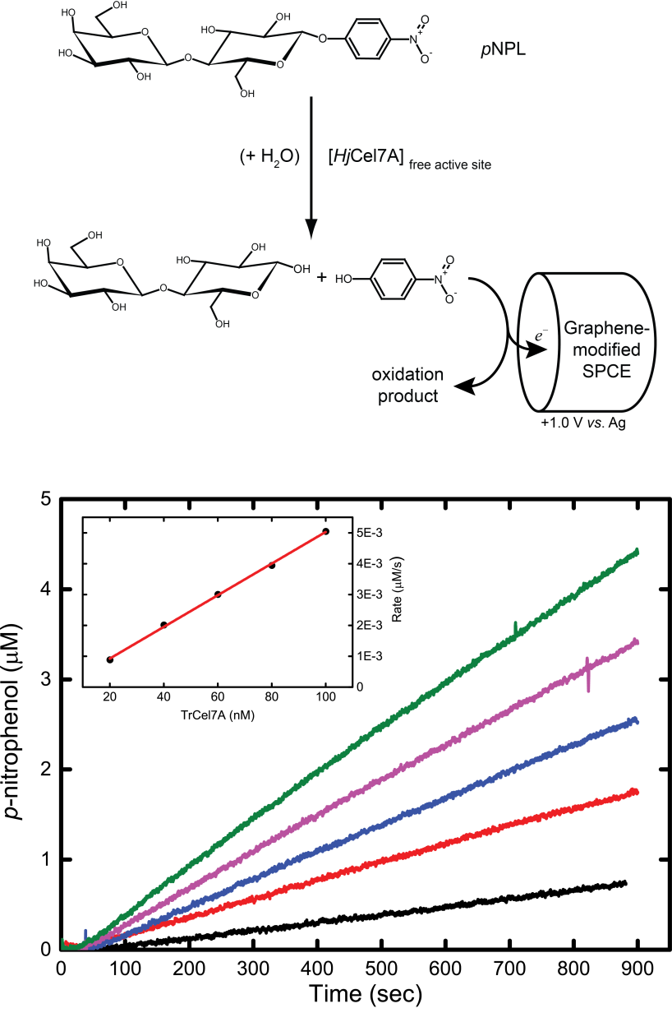
Figure 4. Schematic illustration of the measuring principle. Lower panel: Current response from the anodic detection of released pNP from the enzymatic hydrolysis of pNPL at a fixed concentration of 0.5mM and varying concentration of HjCel7A (20-100 nM). The insert shows the rate of pNP formation vs. the enzyme concentration. The solid red line is the regression line, r²=0.999.
We can now use plots like the line in the insert of Figure 4 as a standard curve for the concentration of enzymes with a free active site in samples which contain both contain 0.5 mM pNPL and different loads of cellulose. Figure 5 shows examples of such measurements with 100 nM HjCel7A, and it appears that the rate of pNPL hydrolysis tapers off as the load of cellulose increases. Unlike the simple case with no cellulose (Figure 4) the raw data in Figure 5 is not linear. This reflects a change in the concentration of the free active sites as the process progresses. The reproducibility of this type of measurements was good as shown in Figure S-5 (Supplementary Information)

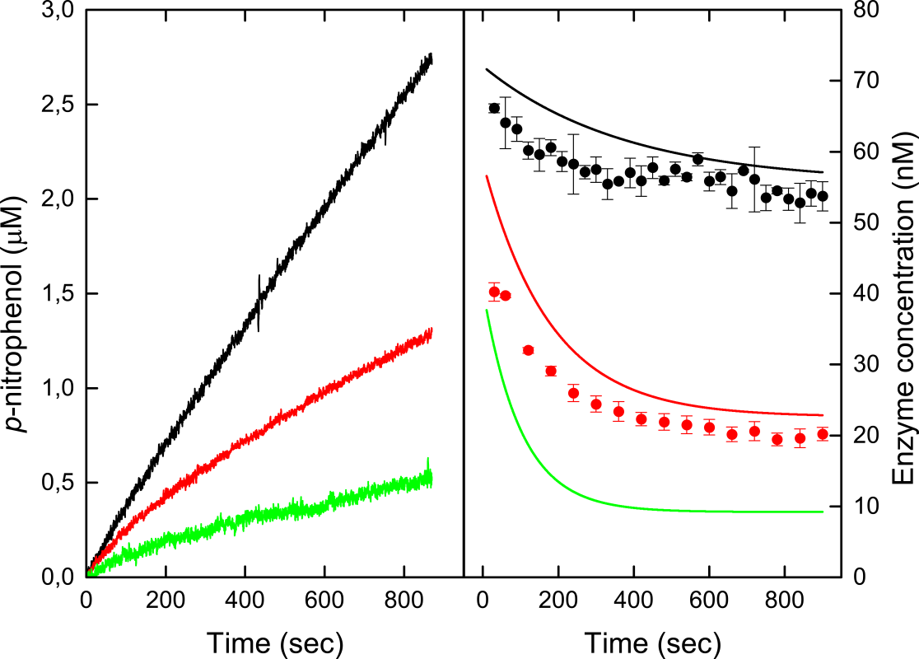
Figure 5. Left-hand panel: Release of pNP by HjCel7A in the presence of different cellulose loads (0.1 g/l (black), 0.5 g/l (red) and 1.0 g/l (green)). Right-hand panel: Temporal changes in the populations of different enzyme forms during hydrolysis of Avicel calculated as described in the main text. The lines show the concentration of enzyme with a free active site (i.e. the sum of “free” and “associated” enzyme in Figure 1) at different cellulose loads (color code as in left-hand panel). The symbols indicate the concentration of free enzyme measured in separate adsorption trials. It follows that the difference between the curves and symbols reflects the concentration of “associated” (i.e. adsorbed but not threaded) enzyme. The concentration of pNPL was 0.5 mM and HjCel7A was 100 nM in al experiments.

To find the rate of hydrolysis at different time points we fitted the function
to the experimental data in Figure 5A. Equation (1) has no theoretical meaning and merely serves to find the slope in Figure 5A and hence the rate of hydrolysis as a function of reaction time. The hydrolytic rate was calculated by inserting the fitted parameters A, B and C in the derivative function
The free active site concentration can now be estimated by inserting hydrolysis rates calculated from eq. in the standard curve in Figure 4. Figure 5 shows examples of this for different cellulose loads. This figure also contains adsorption data for 0.5 g/L and 1.0 g/l cellulose (adsorption data at 0.1 g/l cellulose showed exaggerated scatter). As adsorbed enzyme (see Methods) is defined as the population that is removed from the supernatant, it corresponds to the sum of the associated and threaded states in Figure 1. Hence, we have now quantified “free + associated” from the electrochemical measurements and “associated + threaded” from the absorption data, and combination of this and mass conservation equations allows us to calculate the concentrations of all three states as a function of time. An example of this for a cellulose load of 0.5 g/l is shown in Figure 6. It appears that the threaded form builds up to reach a steady level of about 75% of the total enzyme after 5-8 min. The free form decreases commensurate with this while the associated (un-threaded) only comprises a small fraction.

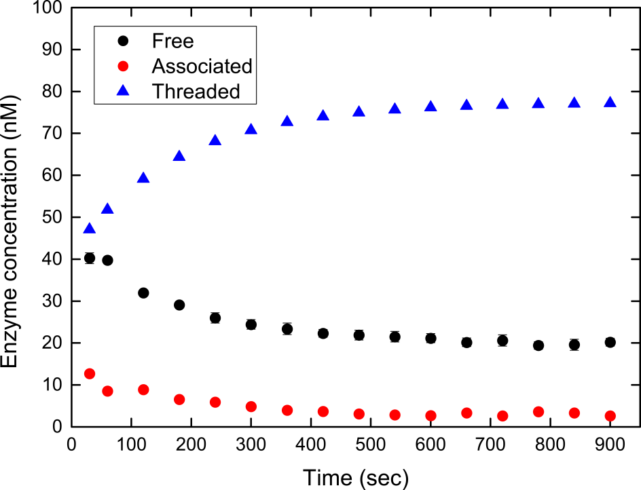
Figure 6. Time course of the three forms of enzyme, free, associated and threaded, specified in Figure 1 for an experiment with 0.5 g/l Avicel and 100 nM HjCel7A.
One avenue to a more detailed analysis of Figure 6 is to assume that the steady state levels for t >~5 min represents an equilibrium distribution of the enzymes under conditions where the total amount of substrate is essentially constant (hydrolysis has only converted a negligible fraction of the cellulose < 0.2% (unpublished data)). We first specify an apparent equilibrium constant for each step in Figure 1,
,
where [Free]_{eq.}, [Associated]_{eq.} and [Threaded]_{eq.} are respectively the free, associated and threaded equilibrium enzyme concentrations. To get the substrate load on a compatible concentration scale we follow the conventional Langmuir approach and introduce the total molar concentration, [S]₀, of binding sites available on the surface of cellulose.
where A_{max} is the maximal binding capacity of the cellulose (in mol of sites /g) and X is the load of substrate (in g/l). For the enzyme-substrate system studied here, A_{max}-values of 0.3-1.1 μmol/g have been reported previously[25; 26] and we will use 1 μmol/g in the following example. The concentration of free binding sites at the apparent equilibrium, [S]_{eq.}, is given by the mass-conservation equation
(5)
and we can therefore get all concentrations on the right-hand sides of eq. using data from Figure 6 and a literature value of A_{max}. Insertion of the average equilibrium values of free, associated and threaded from 600 to 900 sec in Figure 6 into eq. (3) gives K_{adsorp}=0.39 (μM binding sites)⁻¹ and K_{thread}=24. It follows that the overall affinity constant is about 9 (μM binding sites)⁻¹, and this compares favorably with earlier binding studies[25; 26]. More importantly, this result suggests that the affinity of the catalytic domain for the cellulose strand is higher than the affinity of the CBM for the cellulose surface. As a result, the threaded population dominates in Figure 1, while the associated (non-threaded) enzyme makes up less that 5% of the available pool. These observations are pertinent to the question (raised in the Introduction) of whether threading or dissociation are rate limiting for processive cellulases. Clearly, the low population of the intermediate (associated) form in Figure 6 speaks against threading as the bottleneck for the process (in that case an accumulation of the associated form would be expected). This result is in contrast to the conclusions by Kostylev et al.[12] for a different enzyme-substrate system. We suggest that further elucidation of this area will require systematic analysis for different enzymes and substrates at different concentrations, and that the graphene modified SPCE electrode described here provides a manageable experimental approach to this.

Concluding remarks. We have found that graphene modified SPCE can overcome the challenge of electrode fouling from the oxidation product of pNP. This was used to develop an electrochemical assay for the quantification of cellulases with free active site. The measurement relies on the inhibition exerted by cellulose on the hydrolysis of a soluble ‘reporter’ substrate by the cellulase. This principle has previously been used in batch applications, where the activity against the reporter substrate was quantified by absorbance- or fluorescence measurements. A main advantage of the electrochemical assay is that it provides continuous data with a time resolution (~5 sec), which is sufficient to follow an adsorption/threading process as the one in Figure 6. Real-time threading-assays based on absorbance- or fluorescence measurements have not yet been described and may be challenged by both sample turbidity and different solution requirements for respectively enzyme catalysis and optical detection. Thus, two of the most commonly used probes p-nitrophenol and 4-methylumbelliferone are best detected in alkaline solution; far from the optimal pH value for most cellulases. In terms of sensitivity, the new method is comparable to fluorescence- but superior to absorbance assays. In practical terms this means that fluorometry and electrochemistry can be used in cases where concentrations of some of the enzyme species fall as low as about 1 nM. This could, for example, be systems with high substrate load and hence little free and adsorbed (un-treaded) enzyme. The electrochemical method is flexible in the sense that sensor design can be adapted to the experimental setup; including the option of building miniaturized sensors. A main limitation of the electrochemical assay is possible interference from oxidizable molecules in the reaction mixture. While this problem can in general be avoided in work on model substrates in buffer (such as the Avicel studied here), it is may be harder to circumvent in real biomass. However, biomass may also give competing signals in optical methods. All in all we suggest that the current method provides a practicable approach to the analysis of different molecular states of cellulases and hence a useful tool for the development of better molecular descriptions of cellulase mechanisms. This information can be incorporated into kinetic models and hence provide better understanding of rate limiting processes for different types of celluloses and -cellulases. The electrochemical assay may also find wider applications as a highly sensitive, real-time detector for p-nitrophenol, as artificial substrates with this reporter group has been developed for a multiplicity of hydrolytic enzymes.
ACKNOWLEDGMENTS
This work was supported by the Danish Agency for Science, Technology and Innovation, Programme Commission on Sustainable Energy and Environment (grant # 2104-07-0028 to PW), the Ministry of Education, Culture, Sports, Science and Technology in Japan (grant-in-aid for young scientists # 23760746 and special coordination funds for promoting science and technology to HT) and a travel-scholarship to Japan from The Scandinavia-Japan Sasakawa Foundation (http://www.sjsf.se/) (to NC). We are grateful to Helen Ruul and Kadri Alasepp for help with the adsorption measurement’s and Jeppe Kari for help with the preparation of Figure 1.

ABBREVIATIONS
SPCE, Screen-Printed Carbon Electrode; MWCNT, Multi-Walled Carbon Nanotube; SWCNT, Single-Walled Carbon Nanotube; GPH, Graphene; pNP, p-nitrophenol; pNPL, p-nitrophenyl β-D-lactopyranoside;

REFERENCES
[1] Q. Xu, W.S. Adney, S. Ding, and M.E. Himmel, Cellulases for Biomass Conversion. in: J. Polania, and A.P. MacCabe, (Eds.), Industrial enzymes: structure, function and applications, 2007.
[2] D.B. Wilson, Cellulases and biofuels. Current Opinion in Biotechnology 20 (2009) 295-299.
[3] J.M. Fox, S.E. Levine, D.S. Clark, and H.W. Blanch, Initial- and Processive-Cut Products Reveal Cellobiohydrolase Rate Limitations and the Role of Companion Enzymes. Biochemistry 51 (2012) 442-452.
[4] D.B. Wilson, Processive and nonprocessive cellulases for biofuel production-lessons from bacterial genomes and structural analysis. Applied Microbiology and Biotechnology 93 (2012) 497-502.
[5] S.A. Maurer, C.N. Bedbrook, and C.J. Radke, Cellulase Adsorption and Reactivity on a Cellulose Surface from Flow Ellipsometry. Industrial & Engineering Chemistry Research 51 (2012) 11389-11400.
[6] N. Cruys-Bagger, J. Elmerdahl, E. Praestgaard, H. Tatsumi, N. Spodsberg, K. Borch, and P. Westh, Pre-steady-state Kinetics for Hydrolysis of Insoluble Cellulose by Cellobiohydrolase Cel7A. Journal of Biological Chemistry 287 (2012) 18451-18458.
[7] L. Murphy, N. Cruys-Bagger, H.D. Damgaard, M.J. Baumann, S.N. Olsen, K. Borch, S.F. Lassen, M. Sweeney, H. Tatsumi, and P. Westh, Origin of Initial Burst in Activity for Trichoderma reesei endo-Glucanases Hydrolyzing Insoluble Cellulose. Journal of Biological Chemistry 287 (2012) 1252-1260.
[8] J. Jalak, and P. Väljamäe, Mechanism of Initial Rapid Rate Retardation in Cellobiohydrolase Catalyzed Cellulose Hydrolysis. Biotechnology and Bioengineering 106 (2010) 871-883.
[9] J. Jalak, M. Kurasin, H. Teugjas, and P. Väljamäe, Endo-exo Synergism in Cellulose Hydrolysis Revisited. Journal of Biological Chemistry 287 (2012) 28802-28815.
[10] M. Kurasin, and P. Väljamäe, Processivity of Cellobiohydrolases Is Limited by the Substrate. Journal of Biological Chemistry 286 (2011) 169-177.
[11] S.A. Maurer, C.N. Bedbrook, and C.J. Radke, Competitive Sorption Kinetics of Inhibited Endo- and Exoglucanases on a Model Cellulose Substrate. Langmuir 28 (2012) 14598-14608.
[12] M. Kostylev, J.M. Moran-Mirabal, L.P. Walker, and D.B. Wilson, Determination of the molecular states of the processive endocellulase Thermobifida fusca Cel9A during crystalline cellulose depolymerization. Biotechnology and Bioengineering 109 (2012) 295-299.
[13] H. Vantilbeurgh, M. Claeyssens, and C.K. Debruyne, The use of 4-methylumbelliferyl and other chromophoric glycosides in the study of cellulolytic enzymes. FEBS Letters 149 (1982) 152-156.
[14] M.V. Deshpande, K.E. Eriksson, and L.G. Pettersson, An Assay for Selective Determination of Exo-1,4,-beta-glucanases in a Mixture of Cellulotic Enzymes. Analytical Biochemistry 138 (1984) 481-487.
[15] D. Becker, C. Braet, H. Brumer, M. Claeyssens, C. Divne, B.R. Fagerstrom, M. Harris, T.A. Jones, G.J. Kleywegt, A. Koivula, S. Mahdi, K. Piens, M.L. Sinnott, J. Stahlberg, T.T. Teeri, M. Underwood, and G. Wohlfahrt, Engineering of a glycosidase Family 7 cellobiohydrolase to more alkaline pH optimum: the pH behaviour of Trichoderma reesei CeI7A and its E223S/A224H/L225V/T226A/D262G mutant. Biochemical Journal 356 (2001) 19-30.
[16] E. Praestgaard, J. Elmerdahl, L. Murphy, S. Nymand, K.C. McFarland, K. Borch, and P. Westh, A kinetic model for the burst phase of processive cellulases. FEBS Journal 278 (2011) 1547-1560.
[17] M.J. Baumann, K. Borch, and P. Westh, Xylan oligosaccharides and cellobiohydrolase I (TrCel7A) interaction and effect on activity. Biotechnology for Biofuels 4 (2011) 45.
[18] A. Preechaworapun, Z. Dai, Y. Xiang, O. Chailapakul, and J. Wang, Investigation of the enzyme hydrolysis products of the substrates of alkaline phosphatase in electrochemical immunosensing. Talanta 76 (2008) 424-431.
[19] J. Wang, R.P. Deo, and M. Musameh, Stable and sensitive electrochemical detection of phenolic compounds at carbon nanotube modified glassy carbon electrodes. Electroanalysis 15 (2003) 1830-1834.
[20] R.P. Deo, J. Wang, I. Block, A. Mulchandani, K.A. Joshi, M. Trojanowicz, F. Scholz, W. Chen, and Y.H. Lin, Determination of organophosphate pesticides at a carbon nanotube/organophosphorus hydrolase electrochemical biosensor. Analytica Chimica Acta 530 (2005) 185-189.
[21] Y.Y. Shao, J. Wang, H. Wu, J. Liu, I.A. Aksay, and Y.H. Lin, Graphene Based Electrochemical Sensors and Biosensors: A Review. Electroanalysis 22 (2010) 1027-1036.
[22] A. Arvinte, M. Mahosenaho, M. Pinteala, A.M. Sesay, and V. Virtanen, Electrochemical oxidation of p-nitrophenol using graphene-modified electrodes, and a comparison to the performance of MWNT-based electrodes. Microchimica Acta 174 (2011) 337-343.
[23] M. Gruno, P. Väljamäe, G. Pettersson, and G. Johansson, Inhibition of the Trichoderma reesei cellulases by cellobiose is strongly dependent on the nature of the substrate. Biotechnology and Bioengineering 86 (2004) 503-511.
[24] I. von Ossowski, J. Ståhlberg, A. Koivula, K. Piens, D. Becker, H. Boer, R. Harle, M. Harris, C. Divne, S. Mahdi, Y.X. Zhao, H. Driguez, M. Claeyssens, M.L. Sinnott, and T.T. Teeri, Engineering the exo-loop of Trichoderma reesei cellobiohydrolase, Ce17A. A comparison with Phanerochaete chrysosporium Cel7D. Journal of Molecular Biology 333 (2003) 817-829.
[25] L.R. Lynd, P.J. Weimer, W.H. van Zyl, and I.S. Pretorius, Microbial cellulose utilization: Fundamentals and biotechnology. Microbiology and Molecular Biology Reviews 66 (2002) 506-577.
[26] Y.H.P. Zhang, and L.R. Lynd, Toward an aggregated understanding of enzymatic hydrolysis of cellulose: Noncomplexed cellulase systems. Biotechnology and Bioengineering 88 (2004) 797-824.

